Today’s Service
May 16, 2021
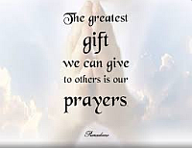
- Call to Worship
- Hymn
- Announcements
- Prayer Requests
- Special Music (Nolan)
- Sermon
From the Pastor
Repentance is a change of mind that results in a change of action. Repentance leads to life (Acts 11:18), and it is a necessary part of salvation. God commands everyone to repent and have faith in Christ (Acts 2:38; 17:30; 20:21). Unrepentance is therefore a serious sin with dire consequences. The unrepentant live in a state of disobedience to God, unheeding of His gracious call. The unrepentant remain unsaved until they turn from their sin and embrace Christ’s blood sacrifice on the cross. Christians should pray for the unrepentant: “Opponents [of the truth] must be gently instructed, in the hope that God will grant them repentance leading them to a knowledge of the truth, and that they will come to their senses and escape from the trap of the devil, who has taken them captive to do his will” (2 Timothy 2:25–26).
Pastor Tony
Church Information
Last Week’s giving:
$1,296+Online $0 = $1,296
Elders
Tony Raker (Pastor)..………………. pastor@graceevfreechurchva.org
Delmas (Moe) Ritenour………………………….. moemar@shentel.net
Finance: Linda Fraley ……………………………….. lindaf12@shentel.net

IT & Media: Rob Moses & Scott Tucker
Bulletin: Rob Moses ………………. admin@graceevfreechurchva.org
Breakfast: Tammy Copeland ……….…tammyscopeland@gmail.com
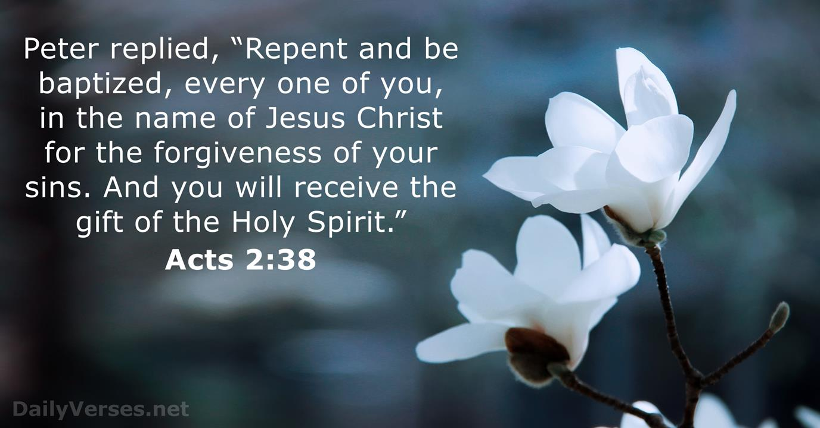
718 E Queen Street, Strasburg, VA 22657, 540-465-4744 msg ph
https://graceevfreechurchva.org
Notes:

Mute cell phone

