Today’s Service
April 5th, 2020
- Call to Worship
- Hymn
- Announcements
- Prayer Requests
- Music
- Sermon
- Communion
- Offering (on table)
From the Pastor
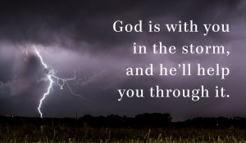
Hebrews 11:1 tells us that faith is “being sure of what we hope for and certain of what we do not see.” Perhaps no other component of the Christian life is more important than faith. Without demonstrating faith and trust in God, we have no place with Him. Most people have a vague, disjointed notion of who God is but lack the reverence necessary for His exalted position in their lives. These people lack the true faith. On the other hand, a true believer’s actions and reactions demonstrate genuine faith. Yes, our faith can falter at times, but because it is the gift of God, given to His children, He provides times of trial and testing in order to prove that our faith is real and to sharpen and strengthen it. This is why James tells us to consider it “pure joy” when we fall into trials, because the testing of our faith produces perseverance and matures us, providing the evidence that our faith is real (James 1:2-4).
Pastor Tony
Church Information
Last Week’s giving: $ 1,231

Elders
Tony Raker (Pastor)..………………. pastor@graceevfreechurchva.org
Delmas (Moe) Ritenour….………………………….. moemar@shentel.net
Finance: Linda Fraley ……………………………….. lindaf12@shentel.net

IT & Media: Rob Moses & Scott Tucker
Bulletin: Rob Moses ………………. admin@graceevfreechurchva.org
Breakfast: Tammy Copeland ……….…tammyscopeland@gmail.com

718 E Queen Street, Strasburg, VA 22657, 540-465-4744 msg ph
https://graceevfreechurchva.org
Please turn off or mute cell phones
Notes:

