Today’s Service
December 22, 2019
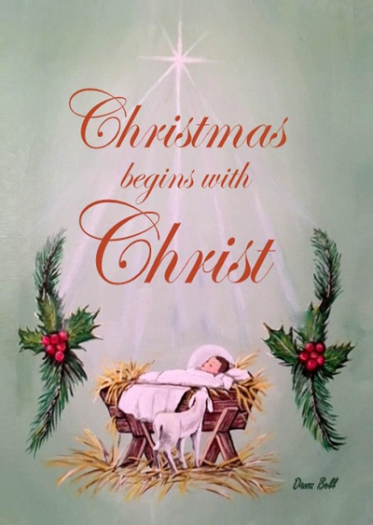
- Call to Worship
- Hymn
- Announcements
- Prayer Requests
- Music
- Sermon
- Offering (on table)
From the Pastor
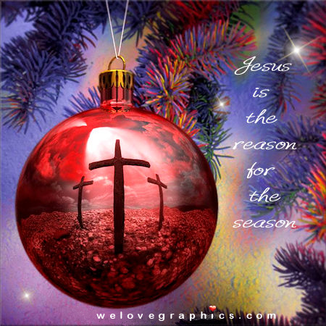
We celebrate Christmas because, as the angel said, “A Savior has been born to you; he is the Messiah, the Lord” (Lk. 2:11). The three titles the angel applies to Jesus are important. Jesus is the Savior who delivers us from sin and death (Mt. 1:21). He is the human Messiah (or Christ) who fulfills the Law and the Prophets, showing that God is faithful (Mt. 5:17). And He is the divine Lord who has entered our world: the Almighty has taken on human flesh; God and man have been fused together in an indivisible, everlasting bond; God is truly with us (Mt. 1:23). In celebrating Christmas we celebrate the love of God (Jn. 3:16). We who have Jesus as Savior truly know, experience and can wish all a Merry Christmas!
Pastor Tony
Church Information
Last Week’s giving: $ 380 Month to date: $ 3,525
Weekly Goal: $ 1,200 Previous month: $ 4,998
2019 Weekly Average: $ 1,115
Elders
Tony Raker (Pastor)..……………………........... tonyraker@yahoo.com
Delmas (Moe) Ritenour….………………………….. moemar@shentel.net
Finance: Linda Fraley ……………………………….. lindaf12@shentel.net

IT & Media: Rob Moses & Scott Tucker
Bulletin: Rob Moses ………………. admin@graceevfreechurchva.org
Breakfast: Tammy Copeland ……….…tammyscopeland@gmail.com
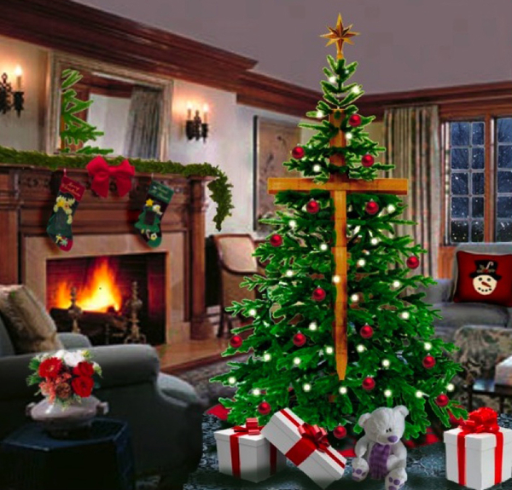
Grace Evangelical Free Church
718 E Queen Street, Strasburg, VA 22657, 540-465-4744 msg ph
https://graceevfreechurchva.org
Please turn off or mute cell phones
Notes:

