Today’s Service
Sept 13th, 2020
- Call to Worship
- Hymn
- Announcements
- Prayer Requests
- Music
- Sermon
- Offering (on table)
From the Pastor
Judgment is a recurring theme throughout the Bible (see Ps. 82:8). God allows difficulties and suffering in the lives of His people to purify them. Persecuted for the cause of Christ, we share in His sufferings (1 Pt. 4:13–14). “Judgment” for the children of God can also be considered discipline (Heb. 12:4–11), designed to purge sin from our lives and teach us obedience. God’s desire is that His people learn to walk in holiness and fellowship with Him (Rom. 8:29). As any loving parent, God will bring unpleasant consequences upon His children for rebellion. He expects the ones He has redeemed by the blood of His Son to set the example for the rest of the world. If the church is not in pursuit of holiness, the world sees no need to change its allegiance. So judgment begins in the household of God, with His own children, as He teaches us to live like Jesus.
Pastor Tony
Church Information

Last Week’s giving:
$1,450
Elders
Tony Raker (Pastor)..………………. pastor@graceevfreechurchva.org
Delmas (Moe) Ritenour….………………………….. moemar@shentel.net
Finance: Linda Fraley ……………………………….. lindaf12@shentel.net

IT & Media: Rob Moses & Scott Tucker
Bulletin: Rob Moses ………………. admin@graceevfreechurchva.org
Breakfast: Tammy Copeland ……….…tammyscopeland@gmail.com
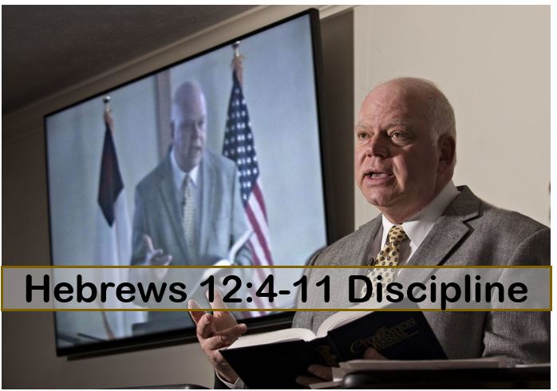

718 E Queen Street, Strasburg, VA 22657, 540-465-4744 msg ph
https://graceevfreechurchva.org
Please turn off or mute cell phones
Notes:

