Today’s Service
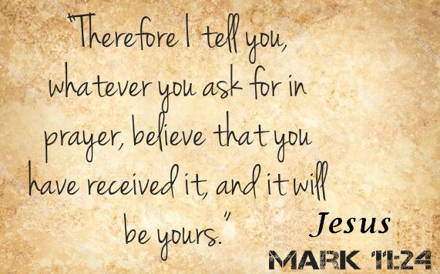
August 11, 2019
- Call to Worship
- Hymn
- Announcements
- Prayer Requests
- Music
- Sermon
- Offering
From the Pastor
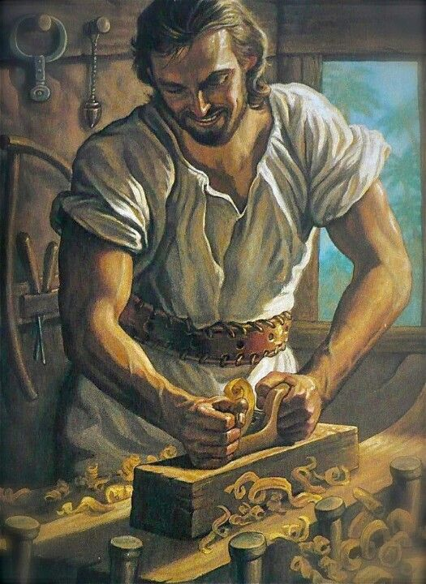
God created human beings to work: the first instruction to Adam was to tend the Garden of Eden (Genesis 2:15). Jesus worked. It would have been understandable if the Son of God had spent all His time in the temple, discussing Scripture. But, for the first thirty years of His life, Jesus worked with his earthly father, Joseph, as a carpenter (Mark 6:3; Luke 2:51-52). Given work was designed by God as man’s earthly occupation, it is the means by which we sustain life and make discoveries about God’s world. We were created in God’s image (Genesis 1:27), a work of God (Psalm 19:1; John 5:19). There our work, as His, is creative, purposeful, and thorough; it is enjoyable to Him and beneficial to us (Psalm 92:4). One day, work will be returned to its pre-fall condition—no curse, just blessing!
Pastor Tony
Church Information
Last Week’s giving: $ 2,730 Month to date: $ 2,730
Weekly Goal: $ 1,200 Previous month: $ 4,370
2019 Weekly Average: $ 1,212
Elders
Tony Raker (Pastor)..……………………........... tonyraker@yahoo.com
Delmas (Moe) Ritenour….………………………….. moemar@shentel.net
Finance: Linda Fraley ……………………………….. lindaf12@shentel.net

IT & Media: Rob Moses & Scott Tucker
Bulletin: Rob Moses ………………. admin@graceevfreechurchva.org
Breakfast: Tammy Copeland ……….…tammyscopeland@gmail.com
Adult Sunday School 9:45 am…………………………………….. Linda Fraley
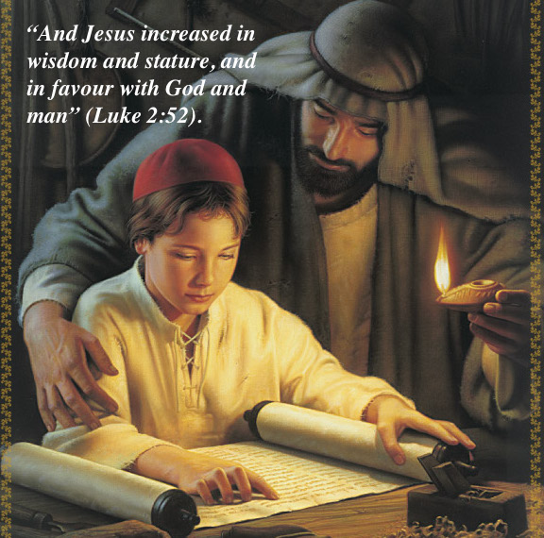
Grace Evangelical Free Church
718 E Queen Street, Strasburg, VA 22657, 540-465-4744 msg ph
https://graceevfreechurchva.org
Please turn off or mute cell phones
Notes:

Next Breakfast is August 17th - Next week!

