Today’s Service
February 23rd , 2020
- Call to Worship
- Hymn
- Announcements
- Prayer Requests
- Music
- Sermon
- Offering (on table)
From the Pastor
We praise the Lord for the conviction of sin. Without it, there could be no salvation. No one is saved apart from the Spirit’s convicting and regenerating work in the heart. When the Holy Spirit convicts people of their sin, He represents the righteous judgment of God (Hebrews 4:12). There is no appeal of this verdict. The Holy Spirit not only convicts people of sin, but He also brings them to repentance (Acts 17:30; Luke 13:5). The Holy Spirit brings to light our relationship to God. The convicting power of the Holy Spirit opens our eyes to our sin and opens our hearts to receive His grace (Ephesians 2:8).

Pastor Tony
Church Information

Last Week’s giving: $ 1,316

Elders
Tony Raker (Pastor)..………………. pastor@graceevfreechurchva.org
Delmas (Moe) Ritenour….………………………….. moemar@shentel.net
Finance: Linda Fraley ……………………………….. lindaf12@shentel.net

IT & Media: Rob Moses & Scott Tucker
Bulletin: Rob Moses ………………. admin@graceevfreechurchva.org
Breakfast: Tammy Copeland ……….…tammyscopeland@gmail.com
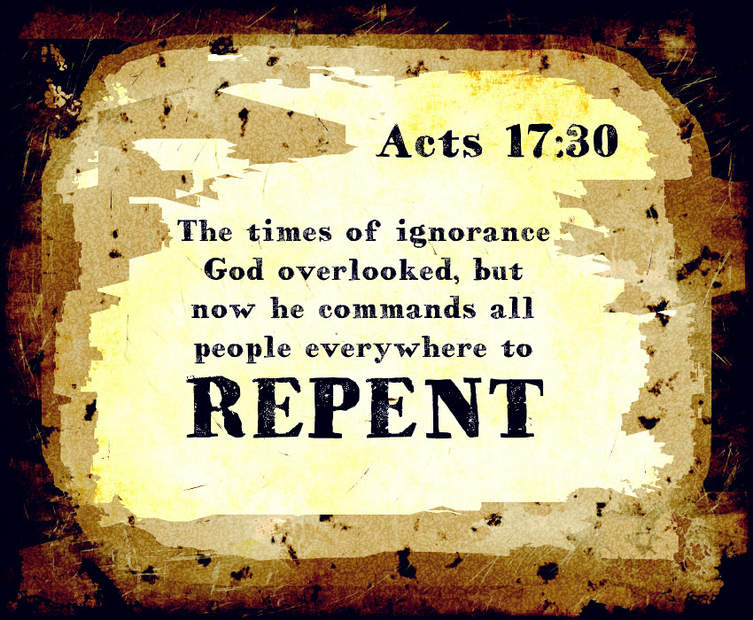

718 E Queen Street, Strasburg, VA 22657, 540-465-4744 msg ph
https://graceevfreechurchva.org
Please turn off or mute cell phones
Notes:

