Today’s Service
March 24, 2019
- Call to Worship
- Hymn
- Announcements
- Prayer Requests
- Music
- Sermon
- Offering
From the Pastor
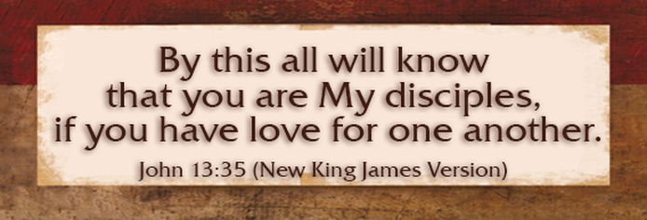
Part of growing up is taking responsibility for oneself. Each one of us has the personal responsibility to “repent and believe the good news” (Mark 1:15) and then to glorify the Lord with good works (Eph. 2:10). Paul’s message to the Ephesians…and to us…is we cannot evade our personal responsibility to exercise faith in Christ which demonstrates itself in our temperament, speech and view of material blessings (Eph. 4:25-32) all couched in God’s love. Jesus said, “By this all people will know that you are my disciples, if you have love for one another” (John 13:35). Our call? Be spiritually responsible, giving way to God’s love, way and will!

Pastor Tony
Church Information
Last Week’s giving: $ 780 Month to date: $ 3,994
Weekly Goal: $ 875 Previous month: $ 4,220
2019 Weekly Average: $ 1,115 Monthly Goal: $ 3,500
Elders
Tony Raker (Pastor)..……………………........... tonyraker@yahoo.com
Delmas (Moe) Ritenour ………………………….. moemar@shentel.net
Finance: Anthony Sinecoff………………………….. sinecoff@gmail.com
Linda Fraley ……………………………….. lindaf12@shentel.net

Media: Rob Moses & Scott Tucker
Bulletin: Rob Moses ………………. admin@graceevfreechurchva.org
Breakfast: Tammy Copeland ……….…tammyscopeland@gmail.com
Adult Sunday School 9:45 am…………………………………….. Linda Fraley

Grace Evangelical Free Church
718 E Queen Street, Strasburg, VA 22657, 540-465-4744 msg ph
https://graceevfreechurchva.org

