Today’s Service
Feb 24, 2019
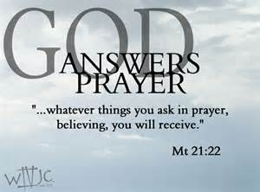
- Call to Worship
- Hymn
- Announcements
- Prayer Requests
- Music
- Sermon
- Offering
From the Pastor
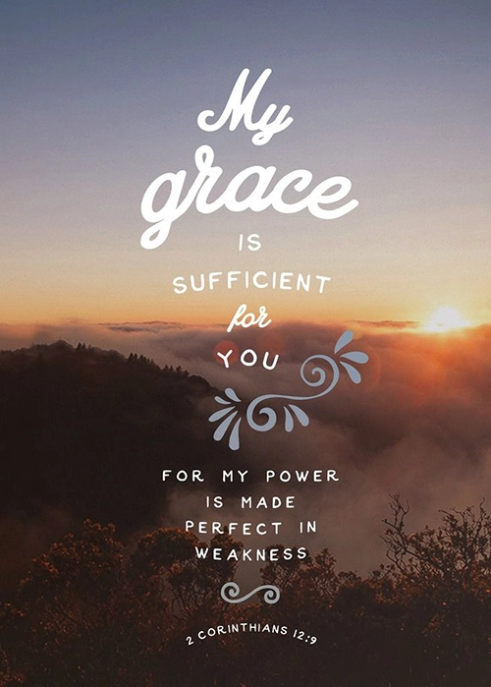
We are not trying to live a holy life in order to earn salvation; living a holy life is a natural outgrowth of being saved by God’s grace and filled with His Spirit. It is also important to not give up when we mess up. When we fail, our response should be to confess the sin and keep moving forward in our Christian walk (1 John 1:9). Romans 8:1 says, “There is now no condemnation for those who are in Christ Jesus.” God’s grace doesn’t go away when we make mistakes, in fact we can invite His correction when we fail to desire, talk and live as we should – yet even that is for our good (Hebrews 12:11).
Pastor Tony
Church Information
Last Week’s giving: $ 80 Month to date: $ 3,040
Weekly Goal: $ 875 Previous month: $ 4,053
2019 Weekly Average: $ 1,013 Monthly Goal: $ 3,500
Elders
Tony Raker (Pastor)..……………………........... tonyraker@yahoo.com
Delmas (Moe) Ritenour ………………………….. moemar@shentel.net
Finance: Anthony Sinecoff………………………….. sinecoff@gmail.com
Linda Fraley ……………………………….. lindaf12@shentel.net

Media: Rob Moses & Scott Tucker
Bulletin: Rob Moses ………………. admin@graceevfreechurchva.org
Breakfast: Tammy Copeland ……….…tammyscopeland@gmail.com
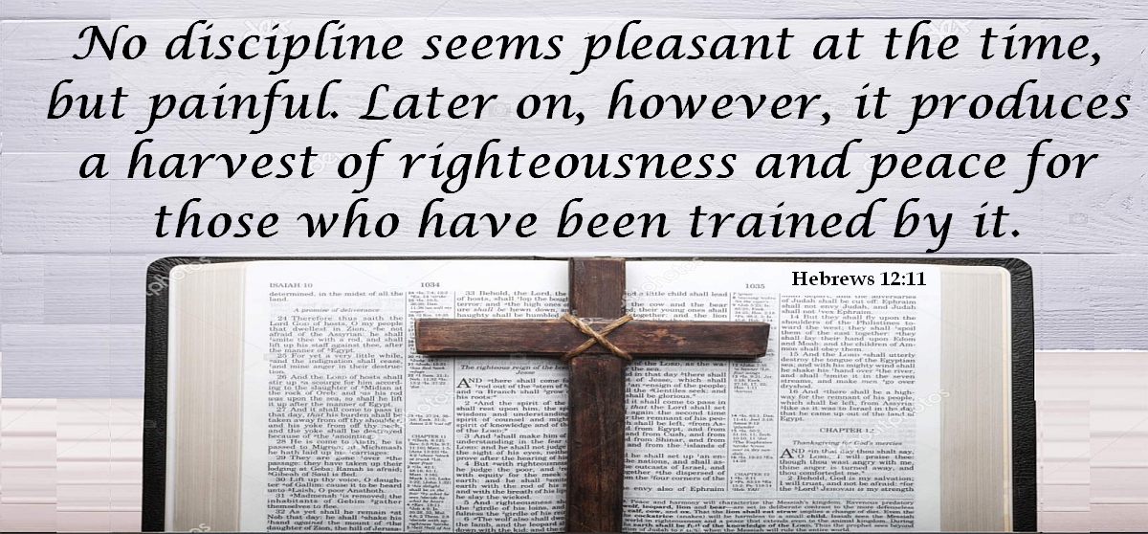
Adult Sunday School 9:45 am…………………………………….. Linda Fraley

Grace Evangelical Free Church
718 E Queen Street, Strasburg, VA 22657, 540-465-4744 msg ph
https://graceevfreechurchva.org
Please turn off or mute cell phones
Notes:

Next Breakfast is March 16th.

Many folks want to serve Jesus –
but only in an advisory capacity.

