Today’s Service
Jan 13, 2019
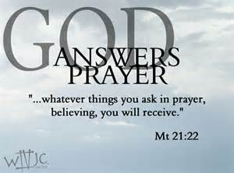
- Call to Worship
- Hymn
- Announcements
- Prayer Requests
- Music
- Sermon
- Offering
From the Pastor
God’s desire is that all people repent and be saved (2 Peter 3:9) yet Satan, the “father of lies” (John 8:44), deceives the very people who need to accept the truth (2 Corinthians 4:4). Deception is the fact that we often choose what we want to believe rather than what we should believe, even in the face of the evidence: “Even after Jesus had done all these miraculous signs in their presence, they still would not believe in him” (John 12:37). The same dynamic is at work today. Anyone who resists God risks falling into spiritual deception (2 Thessalonians 2:8-10). Nature abhors a vacuum, and the void created by the eviction of truth will soon be filled by something less than true. In short, if you won’t believe in Jesus you will be deceived into believe anything else
Pastor Tony
Church Information
Last Week’s giving: $ 2,434 Month to date: $ 2,434
Weekly Goal: $ 875 Previous month: $ 4,940
Weekly Average: & 811 Monthly Goal: $ 3,500
Elders
Tony Raker (Pastor)..……………………........... tonyraker@yahoo.com
Delmas (Moe) Ritenour ………………………….. moemar@shentel.net
Finance: Anthony Sinecoff………………………….. sinecoff@gmail.com
Linda Fraley ……………………………….. lindaf12@shentel.net

Media: Rob Moses & Scott Tucker
Bulletin: Rob Moses ………………. admin@graceevfreechurchva.org
Breakfast: Tammy Copeland ……….…tammyscopeland@gmail.com
Adult Sunday School 9:45 am…………………………………….. Linda Fraley

Grace Evangelical Free Church
718 E Queen Street, Strasburg, VA 22657, 540-465-4744 msg ph
https://graceevfreechurchva.org
Please turn off or mute cell phones
Notes:

Next Breakfast is January 19th.

Eternity is a long time to be wrong

