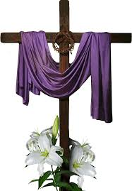
Today’s Service
April 21, 2019
- Call to Worship
- Hymn
- Announcements
- Prayer Requests
- Music
- Sermon
- Offering
From the Pastor
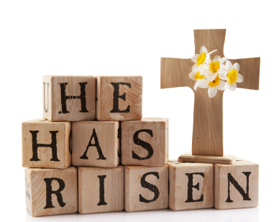
The resurrection is the triumphant and glorious victory for every believer. Jesus Christ died, was buried, and rose the third day according to the Scriptures (1 Corinthians 15:3–4). And He is coming again! The dead in Christ will be raised up, and those who are alive at His coming will be changed and receive new, glorified bodies (1 Thessalonians 4:13–18). Why is the resurrection of Jesus Christ important? It proves who Jesus is. It demonstrates that God accepted Jesus’ sacrifice of His blood on our behalf (Hebrews 9:12). It shows that God has the power to raise us from the dead. It guarantees that the bodies of those who believe in Christ will not remain dead but will be resurrected unto eternal life. Only those who know Jesus as Savior can truly live!
Pastor Tony

Church Information
Last Week’s giving: $ 2,210 Month to date: $ 3,210
Weekly Goal: $ 875 Previous month: $ 7,343
2019 Weekly Average: $ 1,255 Monthly Goal: $ 3,500
Elders
Tony Raker (Pastor)..……………………........... tonyraker@yahoo.com
Delmas (Moe) Ritenour ………………………….. moemar@shentel.net
Finance: Anthony Sinecoff………………………….. sinecoff@gmail.com
Linda Fraley ……………………………….. lindaf12@shentel.net

Media: Rob Moses & Scott Tucker
Bulletin: Rob Moses ………………. admin@graceevfreechurchva.org
Breakfast: Tammy Copeland ……….…tammyscopeland@gmail.com
Adult Sunday School 9:45 am…………………………………….. Linda Fraley
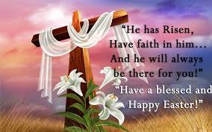
Grace Evangelical Free Church
718 E Queen Street, Strasburg, VA 22657, 540-465-4744 msg ph
https://graceevfreechurchva.org
Please turn off or mute cell phones
Notes:

Next Breakfast is May 18th.

