Today’s Service
April 23, 2023
- Call to Worship
- Hymn
- Announcements
- Prayer Requests
- Special Music
- Sermon
From the Pastor
Reasonable service to God (Rom. 12:1) is expressed through the presentation of our whole bodies to God in gratitude, praise, and worship (1 Cor. 6:19-20; Phil. 1:20-21). In the Old Testament, God’s people “made” sacrifices. Today believers are to “be” sacrifices (1 Cor. 15:58; Mt. 16:24; Phil. 3:8). We offer our bodies not as “slaves to impurity and to ever-increasing wickedness” but “as slaves to righteousness leading to holiness” (Rom. 6:19). Every day that we live to please God and obey His will, we are performing our reasonable service of genuine, wholehearted worship of God.
Pastor Tony
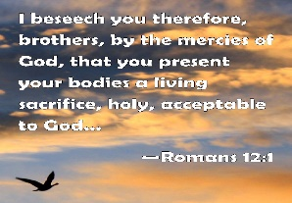

Church Information
Last Week’s Giving: $585.00
Elders
Tony Raker (Pastor)..………………. pastor@graceevfreechurchva.org
Delmas (Moe) Ritenour………………………….. moemar@shentel.net
Finance: Linda Fraley ……………………………….. lindaf12@shentel.net

IT & Media: Scott Tucker
Bulletin: Scott Tucker ………………. admin@graceevfreechurchva.org
Breakfast: Tammy Copeland ……….…tammyscopeland@gmail.com
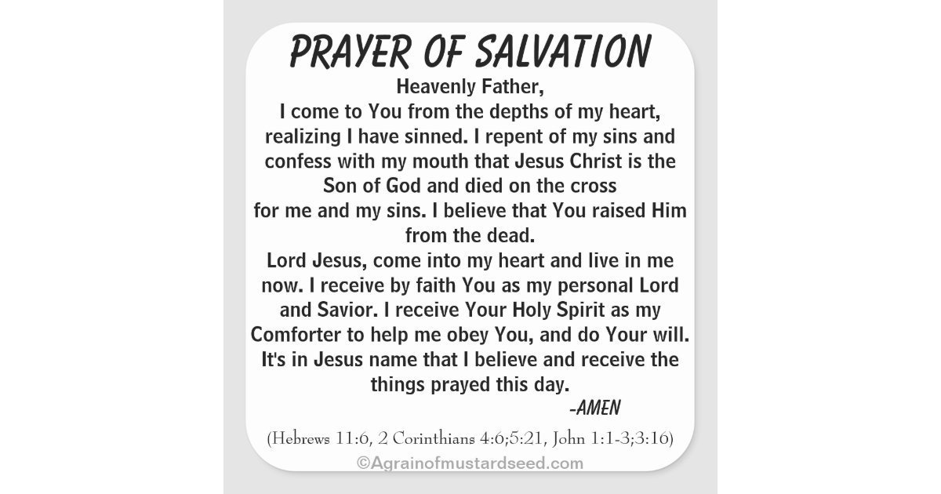

718 E Queen Street, Strasburg, VA 22657, 540-465-4744 msg ph
https://graceevfreechurchva.org
Notes:

Mute cell phone

