Today’s Service
April 30, 2023
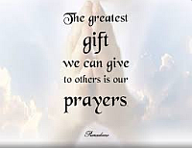
- Call to Worship
- Hymn
- Announcements
- Prayer Requests
- Special Music
- Sermon
From the Pastor
The Holy Spirit is given to us to confirm to us that we belong to God who grants to us His Spirit as a gift (Eph. 2:8-9). Through the gift of the Spirit, God renews and sanctifies us. God grants to us His Holy Spirit evidence that we are His forever. The proof of the Spirit’s presence is His operations on the heart which produce repentance, the fruit of the Spirit (Galatians 5:22-23), conformity to God’s commands and will, a passion for prayer and praise and love for His people. These things are the evidences that the Holy Spirit has renewed the heart and that the Christian is sealed for the day of redemption.
Pastor Tony
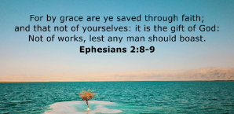

Church Information
Last Week’s Giving: $1,963.00
Elders
Tony Raker (Pastor)..………………. pastor@graceevfreechurchva.org
Delmas (Moe) Ritenour………………………….. moemar@shentel.net
Finance: Linda Fraley ……………………………….. lindaf12@shentel.net

IT & Media: Scott Tucker
Bulletin: Scott Tucker ………………. admin@graceevfreechurchva.org
Breakfast: Tammy Copeland ……….…tammyscopeland@gmail.com
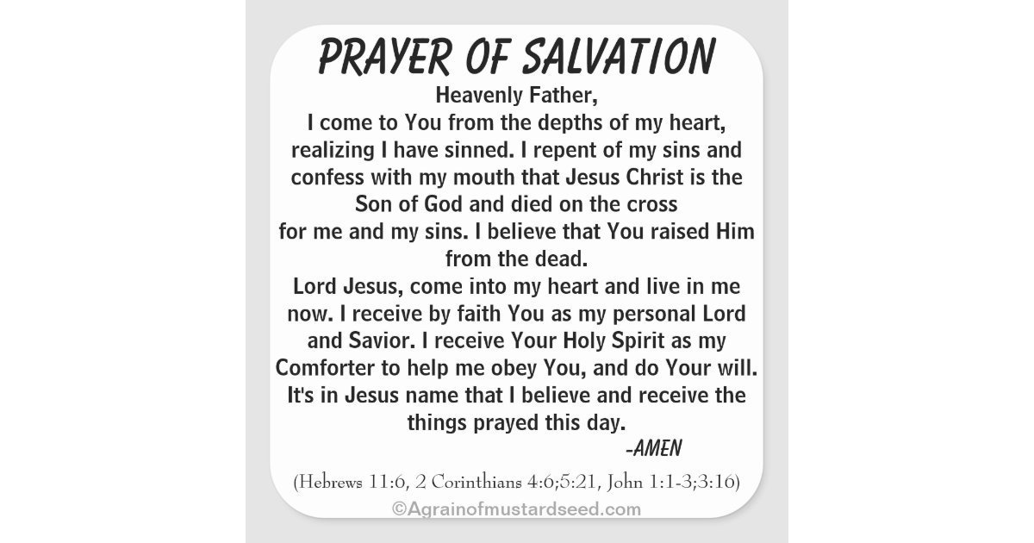

718 E Queen Street, Strasburg, VA 22657, 540-465-4744 msg ph
https://graceevfreechurchva.org
Notes:

Mute cell phone

