Today’s Service
July 28, 2019
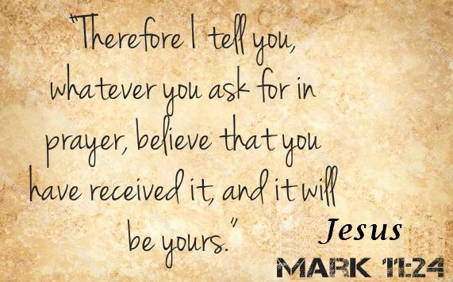
- Call to Worship
- Hymn
- Announcements
- Prayer Requests
- Music
- Sermon
- Offering
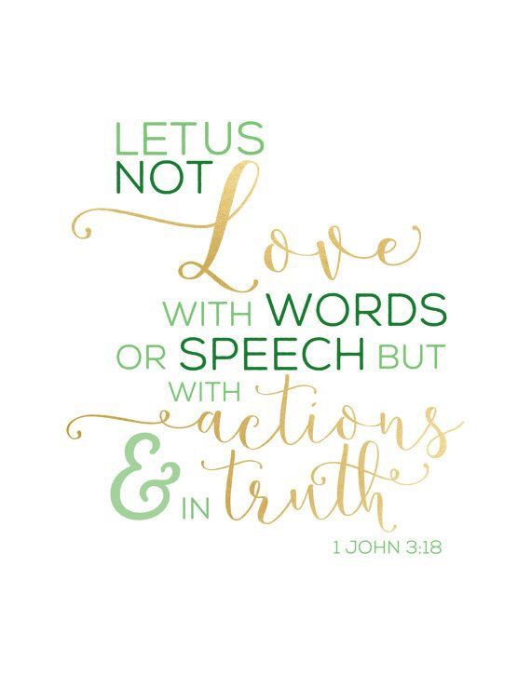
From the Pastor
There is no question that words communicate love, but so do actions. Husbands need to do both. As the Apostle John wrote:
One of the missing ingredients in male leadership in homes is sacrificial action. When was the last time you gave up something for your wife—something you genuinely valued, like your golf game or a fishing trip? Sometimes you need to give up something you enjoy so your wife can have a break which communicates one overriding truth: you love her. To be a leader, a lover, and a servant is to accommodate your life to the gift God has given you—your wife (Proverbs 18:22). Biblically approached and applied, the godly husband at the judgment seat of Christ will hear, “Well done, thou good and faithful servant.”
Pastor Tony
Church Information
Last Week’s giving: $ 1, 150 Month to date: $ 3,860
Weekly Goal: $ 1,200 Previous month: $ 6,125
2019 Weekly Average: $ 1,184
Elders
Tony Raker (Pastor)..……………………........... tonyraker@yahoo.com
Delmas (Moe) Ritenour….………………………….. moemar@shentel.net
Finance: Linda Fraley ……………………………….. lindaf12@shentel.net

IT & Media: Rob Moses & Scott Tucker
Bulletin: Rob Moses ………………. admin@graceevfreechurchva.org
Breakfast: Tammy Copeland ……….…tammyscopeland@gmail.com
Adult Sunday School 9:45 am…………………………………….. Linda Fraley
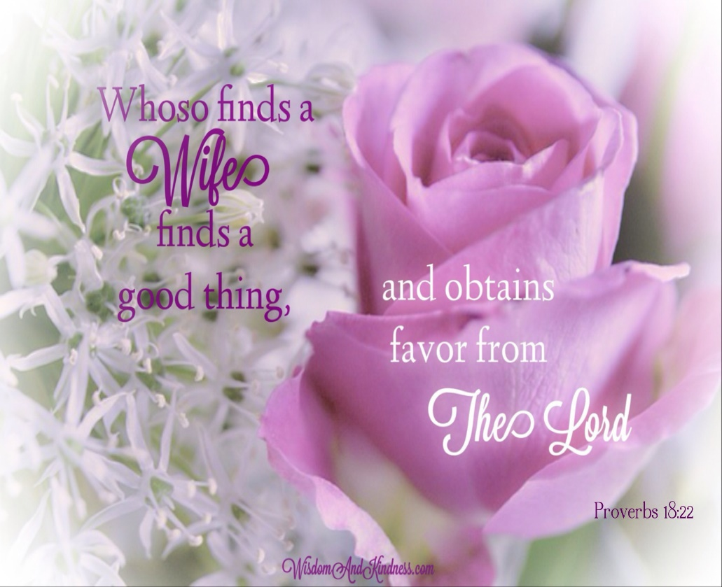
Grace Evangelical Free Church
718 E Queen Street, Strasburg, VA 22657, 540-465-4744 msg ph
https://graceevfreechurchva.org
Please turn off or mute cell phones
Notes:

Next Breakfast is August 17th

