Today’s Service
March 21, 2021
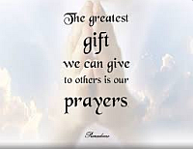
- Call to Worship
- Hymn
- Announcements
- Prayer Requests
- Special Music
- Sermon
From the Pastor
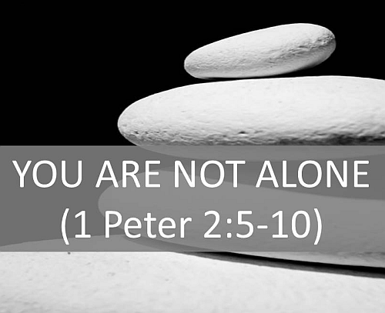
Jesus is the Cornerstone of the Church (1 Peter 2:6), and we are “like living stones . . . being built into a spiritual house to be a holy priesthood, offering spiritual sacrifices acceptable to God through Jesus Christ” (1 Peter 2:5). As the building materials of God’s “spiritual house,” we naturally have a connection with one another, and that connection is evident every time the Church “goes to church.” The Bible tells us we need to attend church so we can worship God with other believers and be taught His Word for our spiritual growth. The early church “devoted themselves to the apostles’ teaching and to fellowship, to the breaking of bread and to prayer” (Acts 2:42). We should follow that example of devotion— and to the same things. Wherever a meeting takes place, believers thrive on fellowship with other believers and the teaching of God’s Word.
Pastor Tony
Church Information
Last Week’s giving:
$616 + Online $300 = $916
Elders
Tony Raker (Pastor)..………………. pastor@graceevfreechurchva.org
Delmas (Moe) Ritenour….………………………….. moemar@shentel.net
Finance: Linda Fraley ……………………………….. lindaf12@shentel.net

IT & Media: Rob Moses & Scott Tucker
Bulletin: Rob Moses ………………. admin@graceevfreechurchva.org
Breakfast: Tammy Copeland ……….…tammyscopeland@gmail.com
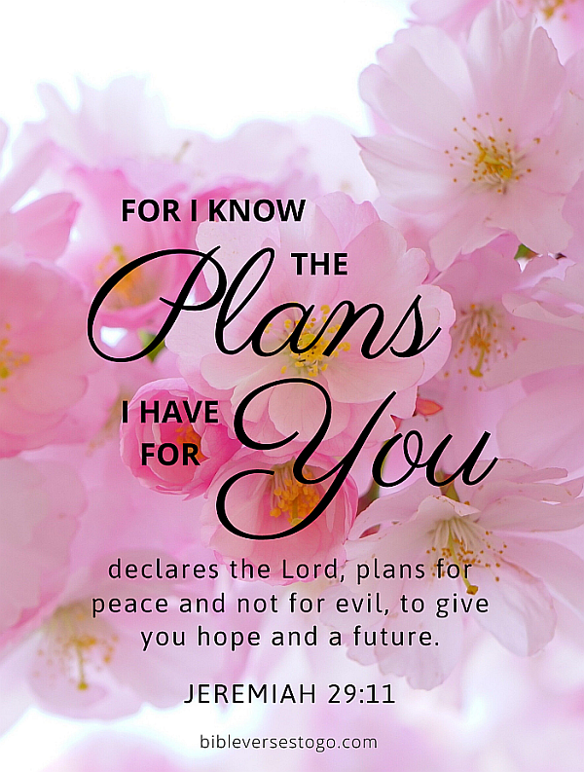
718 E Queen Street, Strasburg, VA 22657, 540-465-4744 msg ph
https://graceevfreechurchva.org
Notes:

