Today’s Service
April 18, 2021
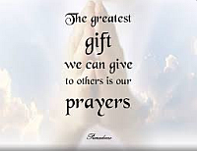
- Call to Worship
- Hymn
- Announcements
- Prayer Requests
- Special Music
- Sermon
From the Pastor
In reference to God, active obedience is seeking out His commands and setting our hearts to do them. Passive obedience is the state of ongoing surrender that says, 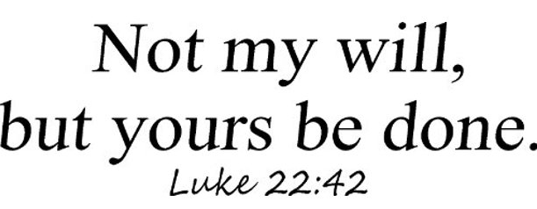following the leading of the Holy Spirit even when harm or suffering may result. Then we endure. With Jesus as our perfect model and the Holy Spirit as our strength, we must pursue lives of both passive and active obedience (Acts 1:8). Failure to do so is to invoke Matthew 10:33: “but whoever denies me before men, I also will deny before my Father who is in heaven.”
Pastor Tony
Church Information
Last Week’s giving:
$642 + Online $0 = $642
Elders
Tony Raker (Pastor)..………………. pastor@graceevfreechurchva.org
Delmas (Moe) Ritenour….………………………….. moemar@shentel.net
Finance: Linda Fraley ……………………………….. lindaf12@shentel.net

IT & Media: Rob Moses & Scott Tucker
Bulletin: Rob Moses ………………. admin@graceevfreechurchva.org
Breakfast: Tammy Copeland ……….…tammyscopeland@gmail.com
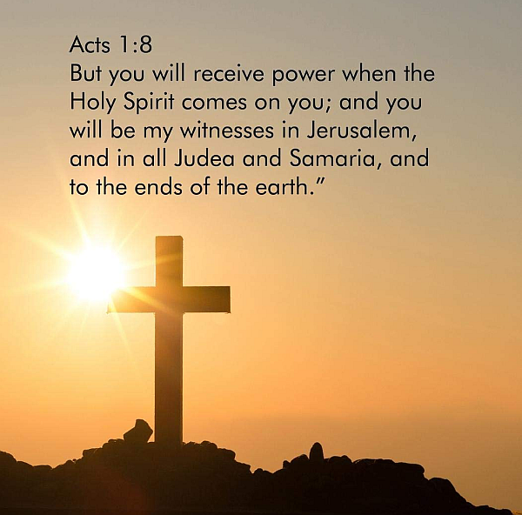
718 E Queen Street, Strasburg, VA 22657, 540-465-4744 msg ph
https://graceevfreechurchva.org
Notes:

