Today’s Service
January 5th 2020
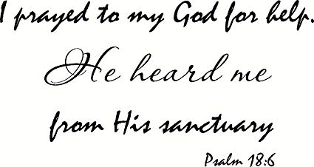
- Call to Worship
- Hymn
- Announcements
- Prayer Requests
- Music
- Sermon
- Communion
- Offering (on table)
From the Pastor
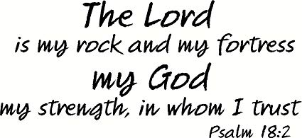
A Christian testimony relates how we came to know Jesus Christ, the God of the Bible through the moving of the Holy Spirit in our hearts. It also includes the ways in which the Lord has worked in our lives to sanctify us for His service. As an example, a testimony could include how He brought us through a difficult time in our life (such as a loss or some sort or a severe illness) and built our faith in Him through that experience. We could also describe the continual process by which the Spirit who now indwells us leads, guides, molds and shapes us into mature Christians. In short, the focus is on the Lord and His faithfulness (Psalm 18:2, 6) – a witness of how God has worked in our lives.
Pastor Tony

Church Information
Last Week’s giving: $ 250 Month to date: $ 5,125
Weekly Goal: $ 1,200 Previous month: $ 4,998
2019 Weekly Average: $ 1,103
Elders
Tony Raker (Pastor)..……………………........... tonyraker@yahoo.com
Delmas (Moe) Ritenour….………………………….. moemar@shentel.net
Finance: Linda Fraley ……………………………….. lindaf12@shentel.net

IT & Media: Rob Moses & Scott Tucker
Bulletin: Rob Moses ………………. admin@graceevfreechurchva.org
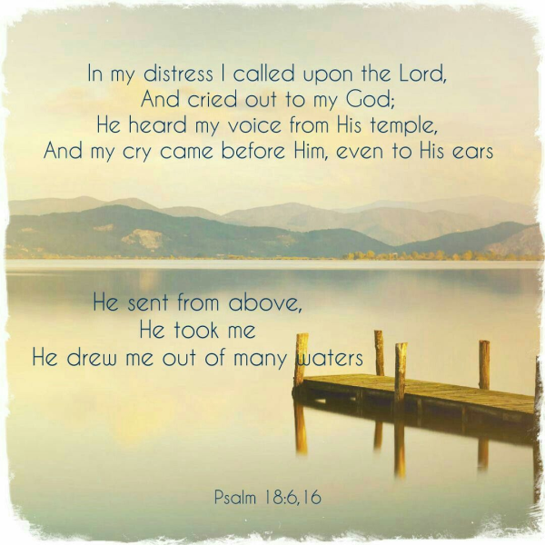
Breakfast: Tammy Copeland ……….…tammyscopeland@gmail.com

Grace Evangelical Free Church
718 E Queen Street, Strasburg, VA 22657, 540-465-4744 msg ph
https://graceevfreechurchva.org
Please turn off or mute cell phones
Notes:

