Today’s Service
January 12th 2020
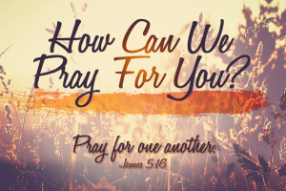
- Call to Worship
- Hymn
- Announcements
- Prayer Requests
- Music
- Sermon
- Offering (on table)
From the Pastor
A distinguishing mark of being a follower of Christ is a deep, sincere love for brothers and sisters in Christ. The apostle John reminds us of this fact: “He has given us this command: anyone who loves God must also love their brother and sister” (1 John 4:21). In giving this command, Jesus did something the world had never seen before—He created a group identified by one thing: love, from which grace or “good will, kindness and favor” (Ephesians 6:24) are freely given and heartily received. For the first and only time in history, Jesus created a group whose identifying factor is love. Skin color doesn’t matter. Native language doesn’t matter. There are no rules about diet or uniforms or social status. Followers of Christ are, simply, identified by their love for God and one other. Give and receive generously!

Pastor Tony
Church Information
Last Week’s giving: $ 3,065 Month to date: $ 3,065
Weekly Goal: $ 1,200 Previous month: $ 5,125
2020 Weekly Average: $ --------
Elders
Tony Raker (Pastor)..……………………........... tonyraker@yahoo.com
Delmas (Moe) Ritenour….………………………….. moemar@shentel.net
Finance: Linda Fraley ……………………………….. lindaf12@shentel.net

IT & Media: Rob Moses & Scott Tucker
Bulletin: Rob Moses ………………. admin@graceevfreechurchva.org
Breakfast: Tammy Copeland ……….…tammyscopeland@gmail.com

Grace Evangelical Free Church
718 E Queen Street, Strasburg, VA 22657, 540-465-4744 msg ph
https://graceevfreechurchva.org
Please turn off or mute cell phones
Notes:

