Today’s Service
January 19th 2020
- Call to Worship
- Hymn
- Announcements
- Prayer Requests
- Music
- Sermon
- Offering (on table)
From the Pastor
Many times anxiety, distress or debilitating concern is a result of sin, and the cure is to deal with the sin. Ps. 32:1-5 says that the person whose sin is forgiven is blessed, and the heavy weight of guilt is taken away when sins are confessed. Is a broken relationship creating anxiety? Try to make peace (2 Cor. 13:11). Is fear of the unknown leading to distress? Turn the situation over to the God who knows everything and is in control of it all (Ps. 68:20). Are overwhelming circumstances causing debilitating concern? Have faith in God. When the disciples became distressed in a storm, Jesus first rebuked their lack of faith, then rebuked the wind and the waves (Mt. 8:23-27). We can count on the Lord to provide for our needs, protect us from evil, guide us, and keep our souls secure for eternity all the while practicing the right response to life’s challenges: Phil. 4:6, 7.
Pastor Tony
Church Information
Last Week’s giving: $ 115 Month to date: $ 3,180
Weekly Goal: $ 1,200 Previous month: $ 5,125
2020 Weekly Average: $ 1580
Elders
Tony Raker (Pastor)..……………………........... tonyraker@yahoo.com
Delmas (Moe) Ritenour….………………………….. moemar@shentel.net
Finance: Linda Fraley ……………………………….. lindaf12@shentel.net

IT & Media: Rob Moses & Scott Tucker
Bulletin: Rob Moses ………………. admin@graceevfreechurchva.org
Breakfast: Tammy Copeland ……….…tammyscopeland@gmail.com
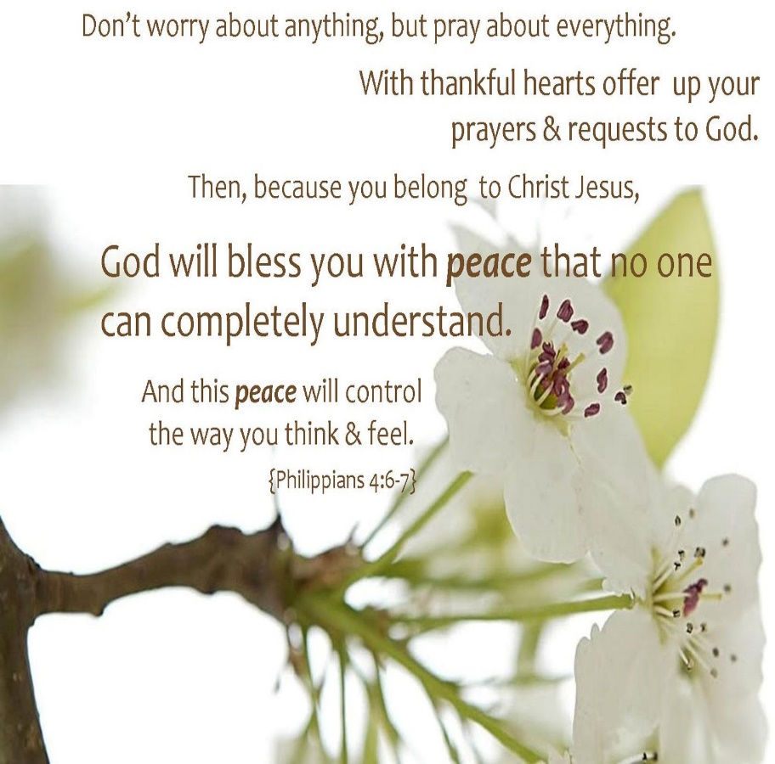

Grace Evangelical Free Church
718 E Queen Street, Strasburg, VA 22657, 540-465-4744 msg ph
https://graceevfreechurchva.org
Please turn off or mute cell phones
Notes:

