Today’s Service
January 26th 2020
- Call to Worship
- Hymn
- Announcements
- Prayer Requests
- Music
- Sermon
- Offering (on table)
From the Pastor
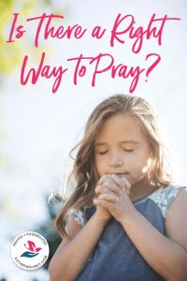
What is the proper way to pray? Philippians 4:6-7 tells us to pray without being anxious, to pray about everything, and to pray with thankful hearts. God will answer all such prayers with the gift of His peace in our hearts. The proper way to pray is to pour out our hearts to God, being honest and open with God, as He already knows us better than we know ourselves. We are to present our requests to God, keeping in mind that God knows what is best and will not grant a request that is not His will for us. We are to express our love, gratitude, and worship to God in prayer without worrying about having just the right words to say. God is more interested in the content of our hearts than the eloquence of our words.
Pastor Tony
Church Information
Last Week’s giving: $ 1,215 Month to date: $ 4,430
Weekly Goal: $ 1,200 Previous month: $ 5,125
2020 Weekly Average: $ 1477
Elders
Tony Raker (Pastor)..……………………........... tonyraker@yahoo.com
Delmas (Moe) Ritenour….………………………….. moemar@shentel.net
Finance: Linda Fraley ……………………………….. lindaf12@shentel.net

IT & Media: Rob Moses & Scott Tucker
Bulletin: Rob Moses ………………. admin@graceevfreechurchva.org
Breakfast: Tammy Copeland ……….…tammyscopeland@gmail.com
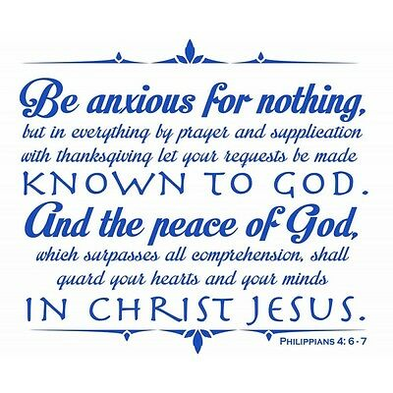

Grace Evangelical Free Church
718 E Queen Street, Strasburg, VA 22657, 540-465-4744 msg ph
https://graceevfreechurchva.org
Please turn off or mute cell phones
Notes:

