Today’s Service
March 8th, 2020
- Call to Worship
- Hymn
- Announcements
- Prayer Requests
- Music
- Sermon
- Offering (on table)
From the Pastor
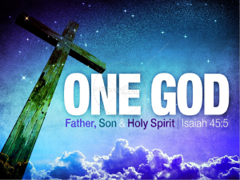
We know there is only one Lord God, but sometimes the Bible references other gods and lords. For example, in Dt. 10:17 we find, “The LORD your God is God of gods and Lord of lords, the great God, mighty and awesome.” Whoever these other “gods” and “lords” are, they cannot compete with the “great God, mighty and awesome.” The emphasis in this verse is God’s supremacy. The focus is on God’s greatness and might. When He is called “God of gods,” we understand it as a reference to the God who is more powerful and greater than any other so-called god. The verse does not teach the existence of other real gods. Rather, God says, “I am the LORD, and there is no other; apart from me there is no God” (Is. 45:5). See also Is. 43:11. Being the “God of gods,” the One True God towers over anything else that might be worshiped. He alone is worthy of worship (Dt. 10:21).
Pastor Tony
Church Information
Last Week’s giving: $ 1,316

Elders
Tony Raker (Pastor)..………………. pastor@graceevfreechurchva.org
Delmas (Moe) Ritenour….………………………….. moemar@shentel.net
Finance: Linda Fraley ……………………………….. lindaf12@shentel.net

IT & Media: Rob Moses & Scott Tucker
Bulletin: Rob Moses ………………. admin@graceevfreechurchva.org
Breakfast: Tammy Copeland ……….…tammyscopeland@gmail.com
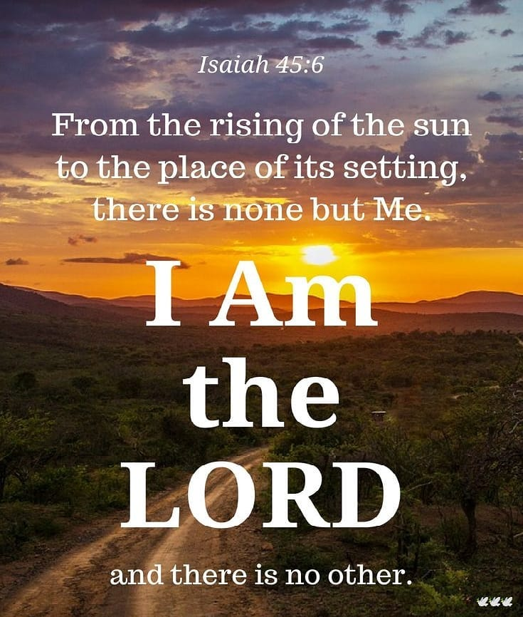

718 E Queen Street, Strasburg, VA 22657, 540-465-4744 msg ph
https://graceevfreechurchva.org
Please turn off or mute cell phones
Notes:

God’s beauty is all around us.

