Today’s Service
March22th, 2020
- Call to Worship
- Hymn
- Announcements
- Prayer Requests
- Music
- Sermon
- Offering (on table)
From the Pastor
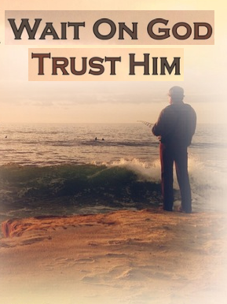
To wait on the Lord is to rest in the confident assurance that, regardless of the details or difficulties we face in this life, God never leaves us without a sure defense. As Moses told the panicky Israelites trapped at the Red Sea by Pharaoh’s army, “The Lord will fight for you; you need only to be still” (Exodus 14:14). The heavenly perspective comes as we focus not on the trouble but on the Lord and His Word. When it seems God has painted us into a corner, we have an opportunity to set aside our human viewpoint and wait upon the Lord to show us His power, His purpose, and His salvation.
Pastor Tony
Church Information
Last Week’s giving: $ 300

Elders
Tony Raker (Pastor)..………………. pastor@graceevfreechurchva.org
Delmas (Moe) Ritenour….………………………….. moemar@shentel.net
Finance: Linda Fraley ……………………………….. lindaf12@shentel.net

IT & Media: Rob Moses & Scott Tucker
Bulletin: Rob Moses ………………. admin@graceevfreechurchva.org
Breakfast: Tammy Copeland ……….…tammyscopeland@gmail.com

718 E Queen Street, Strasburg, VA 22657, 540-465-4744 msg ph
https://graceevfreechurchva.org
Please turn off or mute cell phones
Notes:

