Today’s Service
March29th, 2020
- Call to Worship
- Hymn
- Announcements
- Prayer Requests
- Music
- Sermon
- Offering (on table)
From the Pastor
God answer prayer? The short answer to this question is, “Yes!” God has promised that, when we ask for things that are in accordance with His will for our lives, He will give us what we ask for (1 Jn. 5:14–15). Sometimes hearing “wait” is even harder than hearing “no” because it means we have to be patient (Rom. 8:25). While waiting is difficult, we can be thankful God is in control and trust that His timing will be perfect (Rom. 2:12; Ps. 37:7—9). Yet we are assured that God wants the best for your life. He does not want you to suffer needlessly. Jer. 29:11 says, “For I know the plans I have for you, declares the Lord, plans for welfare and not for evil, to give you a future and a hope.” Be patient and know that He is your loving Father (Ps. 46:10). Abide by Phil. 4:6 as you make your requests to God: “Do not be anxious about anything, but in everything by prayer and supplication with thanksgiving let your requests be made known to God.” Then, when God responds, be prepared to accept His wisdom—whether or not you agree with His answer.
Pastor Tony
Church Information
Last Week’s giving: $ 1,800

Elders
Tony Raker (Pastor)..………………. pastor@graceevfreechurchva.org
Delmas (Moe) Ritenour….………………………….. moemar@shentel.net
Finance: Linda Fraley ……………………………….. lindaf12@shentel.net

IT & Media: Rob Moses & Scott Tucker
Bulletin: Rob Moses ………………. admin@graceevfreechurchva.org
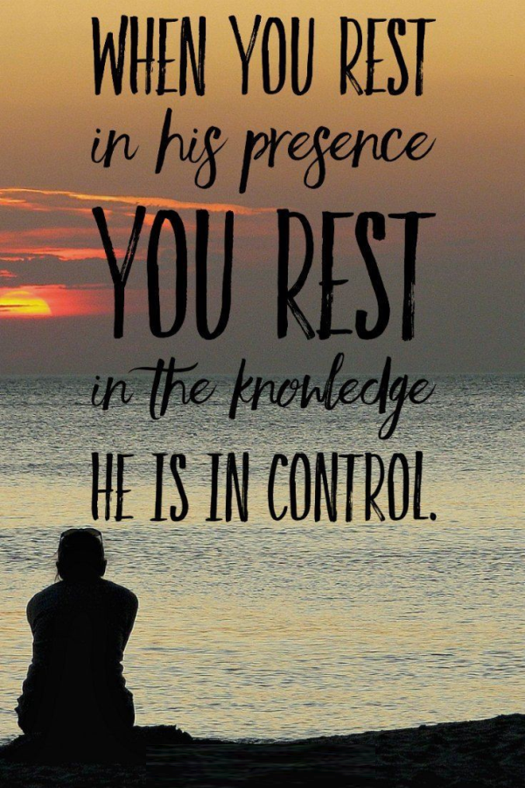
Breakfast: Tammy Copeland ……….…tammyscopeland@gmail.com

718 E Queen Street, Strasburg, VA 22657, 540-465-4744 msg ph
https://graceevfreechurchva.org
Please turn off or mute cell phones
Notes:

