Today’s Service
April 12th, 2020
- Call to Worship
- Hymn
- Announcements
- Prayer Requests
- Music
- Sermon
- Offering (on table)
From the Pastor
The Word of God guarantees the believer’s resurrection at the coming of Jesus Christ. Such assurance results in a great triumph as Paul writes in 1 Cor. 15:55, “Where, O death, is your victory? Where, O death, is your sting?” The importance of the resurrection of Christ also has an impact on our service to the Lord now. Paul ends his discourse on resurrection with these words: “Therefore, my dear brothers and sisters, stand firm. Let nothing move you. Always give yourselves fully to the work of the Lord, because you know that your labor in the Lord is not in vain” (1 Cor. 15:58). Because we know we will be resurrected to new life, we can endure persecution and danger in this life for Christ’s sake (vv 30–32), just as our Lord did. The resurrection is the triumphant and glorious victory for every believer in Jesus!
Pastor Tony
Church Information
Last Week’s giving: $ 1,150

Elders
Tony Raker (Pastor)..………………. pastor@graceevfreechurchva.org
Delmas (Moe) Ritenour….………………………….. moemar@shentel.net
Finance: Linda Fraley ……………………………….. lindaf12@shentel.net

IT & Media: Rob Moses & Scott Tucker
Bulletin: Rob Moses ………………. admin@graceevfreechurchva.org
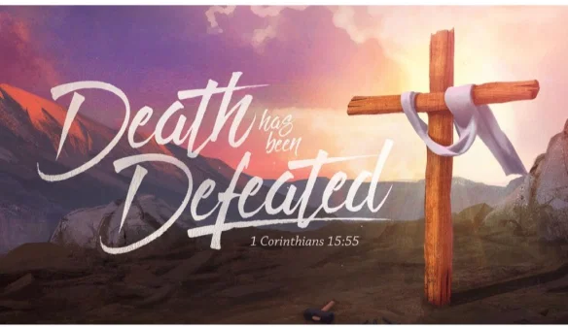
Breakfast: Tammy Copeland ……….…tammyscopeland@gmail.com

718 E Queen Street, Strasburg, VA 22657, 540-465-4744 msg ph
https://graceevfreechurchva.org
Please turn off or mute cell phones
Notes:

