Today’s Service
April 19th, 2020
- Call to Worship
- Hymn
- Announcements
- Prayer Requests
- Music
- Sermon
- Offering (on table)
From the Pastor
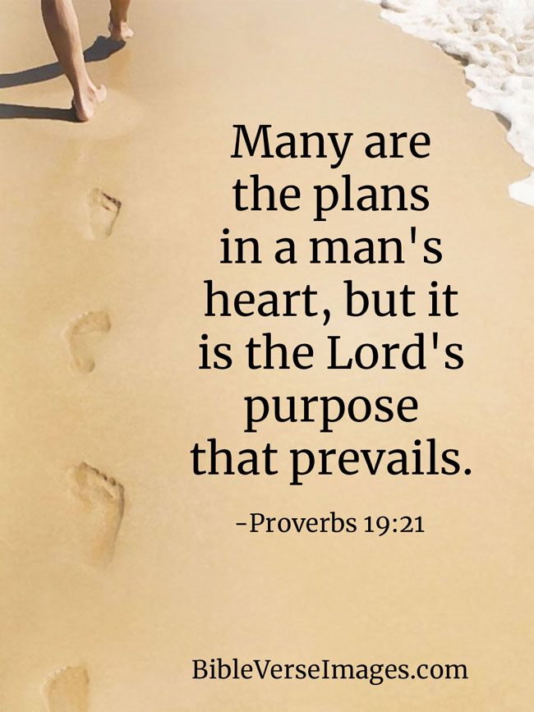
Depending on God is basic to the Christian life. We trust in, or depend on, God for our salvation (Ephesians 2:8–9). We depend on God for wisdom (James 1:5). In fact, we depend on God for everything (Psalm 104:27) and in everything (Proverbs 3:5–6). The psalmist teaches the Lord’s reliability with the three-fold description “the LORD is my rock, my fortress and my deliverer” (Psalm 18:2). Therefore, keeping some of the anxiety on ourselves is to doubt God’s care. Instead, trust that God’s plan for you will prevail (Proverbs 19:21). Just as a child trusts a loving father, we can trust our heavenly Father to always be…and do…what is right.
Pastor Tony
Church Information
Last Week’s giving: $ 2,000

Elders
Tony Raker (Pastor)..………………. pastor@graceevfreechurchva.org
Delmas (Moe) Ritenour….………………………….. moemar@shentel.net
Finance: Linda Fraley ……………………………….. lindaf12@shentel.net

IT & Media: Rob Moses & Scott Tucker
Bulletin: Rob Moses ………………. admin@graceevfreechurchva.org
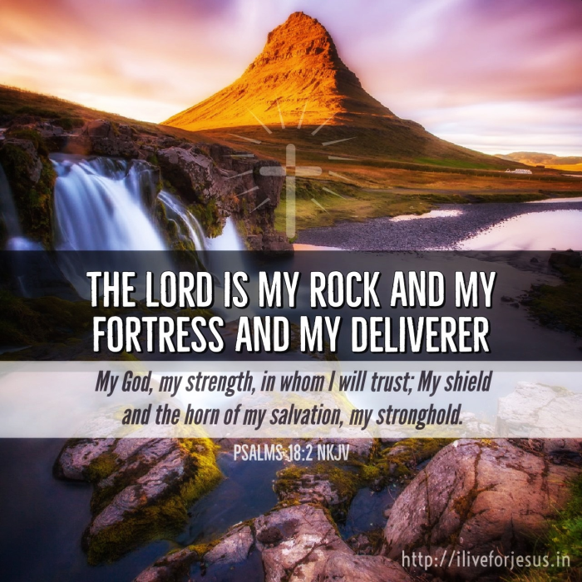
Breakfast: Tammy Copeland ……….…tammyscopeland@gmail.com

718 E Queen Street, Strasburg, VA 22657, 540-465-4744 msg ph
https://graceevfreechurchva.org
Please turn off or mute cell phones
Notes:

