Today’s Service
April 26th, 2020
- Call to Worship
- Hymn
- Announcements
- Prayer Requests
- Music
- Sermon
- Offering (on table)
From the Pastor
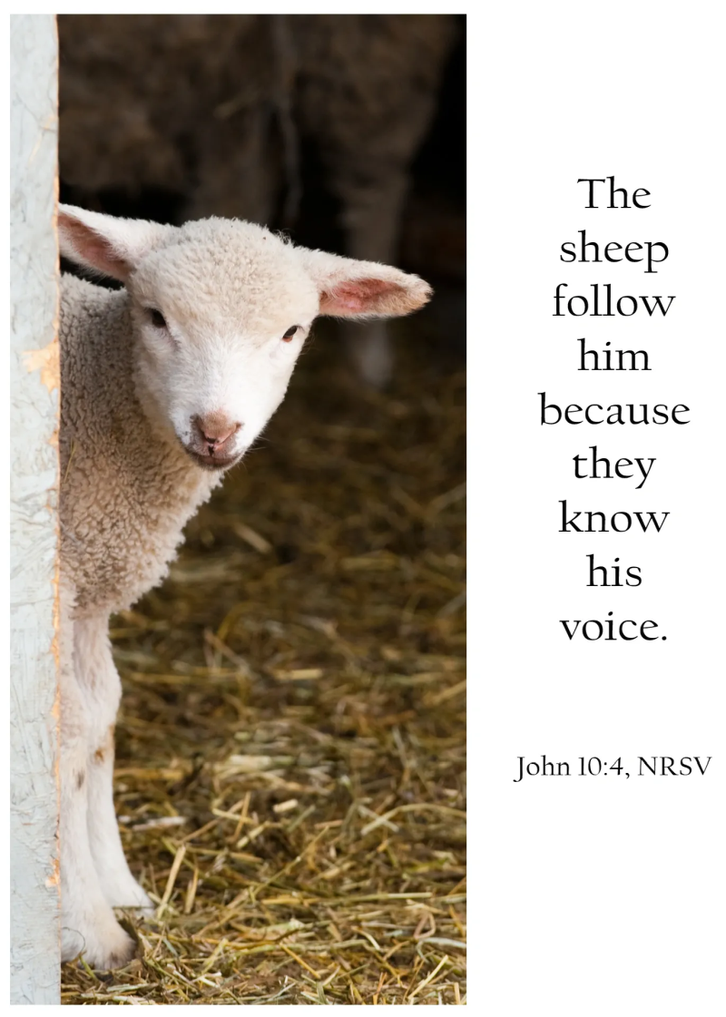
The Greek word for “thief” used in Jn. 10:10 means “one who steals” which, while referring to theft of money or objects, figuratively, the same word is used to refer to false teachers. Spiritually God’s sheep are protected from the thief by their Shepherd. Jesus said, “I am the good shepherd. The good shepherd lays down his life for the sheep” (Jn. 10:11). The sheep “follow him because they know his voice. But they will never follow a stranger; in fact, they will run away from him because they do not recognize a stranger’s voice” (Jn. 10:4–5). It is by knowing truth, knowing God’s voice that we defend against the deceptions of those who would seek to steal, kill, and destroy. Life is in Jesus and Him alone.
Pastor Tony
Church Information
Last Week’s giving: $ 0

Elders
Tony Raker (Pastor)..………………. pastor@graceevfreechurchva.org
Delmas (Moe) Ritenour….………………………….. moemar@shentel.net
Finance: Linda Fraley ……………………………….. lindaf12@shentel.net

IT & Media: Rob Moses & Scott Tucker
Bulletin: Rob Moses ………………. admin@graceevfreechurchva.org
Breakfast: Tammy Copeland ……….…tammyscopeland@gmail.com
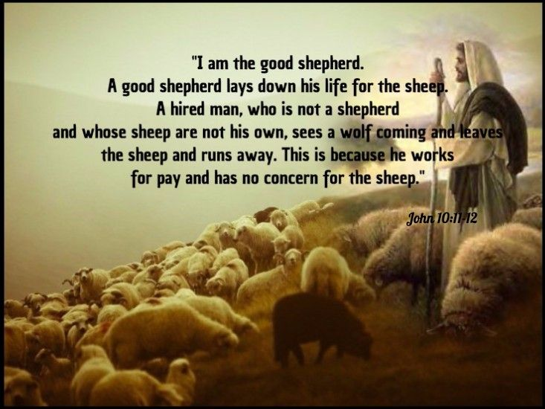

718 E Queen Street, Strasburg, VA 22657, 540-465-4744 msg ph
https://graceevfreechurchva.org
Please turn off or mute cell phones
Notes:

