Today’s Service
May 1, 2020
- Call to Worship
- Hymn
- Announcements
- Prayer Requests
- Music
- Sermon
- Communion
- Offering (on table)
From the Pastor
Any preoccupation, obsession or fascination with anything other than God is sinful and displeasing to God (Dt. 6:5). We are easily drawn in by the "deceitfulness of wealth" (Mark 4:19), thinking that we will be happy, fulfilled or content if only we had more of whatever it is we are chasing. If materialism was ever to satisfy anyone, it would have been Solomon, the richest king the world has ever known. He had absolutely everything and had more of it than anyone, and yet he found it was all worthless and futile. It did not produce happiness or the satisfaction our souls long for. He declared, "Whoever loves money never has money enough; whoever loves wealth is never satisfied with his income" (Ec. 5:10). In the end, Solomon came to the conclusion that we are to "fear God, and keep His commandments. For this is the whole duty of man" (Ec. 12:13).
Pastor Tony
Church Information
Last Week’s giving: $1,40 0

Elders
Tony Raker (Pastor)..………………. pastor@graceevfreechurchva.org
Delmas (Moe) Ritenour….………………………….. moemar@shentel.net
Finance: Linda Fraley ……………………………….. lindaf12@shentel.net

IT & Media: Rob Moses & Scott Tucker
Bulletin: Rob Moses ………………. admin@graceevfreechurchva.org
Breakfast: Tammy Copeland ……….…tammyscopeland@gmail.com
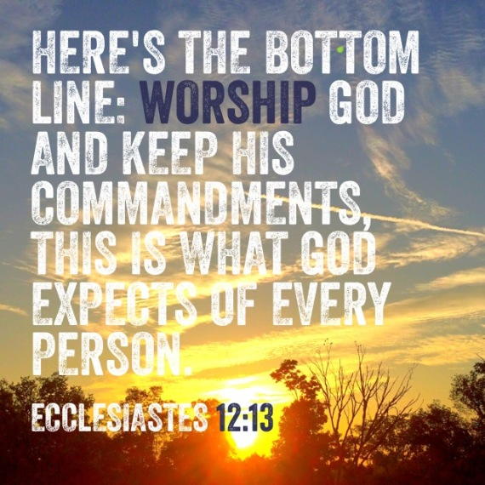

718 E Queen Street, Strasburg, VA 22657, 540-465-4744 msg ph
https://graceevfreechurchva.org
Please turn off or mute cell phones
Notes:

