Today’s Service
May 10, 2020
- Call to Worship
- Hymn
- Announcements
- Prayer Requests
- Music
- Sermon
- Offering (on table)
From the Pastor
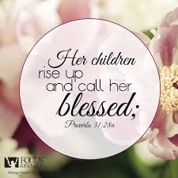
The Proverbs 31 woman is a picture of a godly mother. Although she puts her children and husband first, they are not her entire world. She develops her gifts and uses them to benefit her family and her community. She is a credit to her husband and a role model for her children. She lives with integrity at home and in public, and she presents herself honorably. Verse 28 gives us the result of her years of faithful mothering. After she has poured her life into them, “her children rise up and call her blessed” as the love, care, nurture, and encouragement a mother gives should never cease.
Pastor Tony
Church Information
Last Week’s giving: $1,3750

Elders
Tony Raker (Pastor)..………………. pastor@graceevfreechurchva.org
Delmas (Moe) Ritenour….………………………….. moemar@shentel.net
Finance: Linda Fraley ……………………………….. lindaf12@shentel.net

IT & Media: Rob Moses & Scott Tucker
Bulletin: Rob Moses ………………. admin@graceevfreechurchva.org
Breakfast: Tammy Copeland ……….…tammyscopeland@gmail.com

718 E Queen Street, Strasburg, VA 22657, 540-465-4744 msg ph
https://graceevfreechurchva.org
Please turn off or mute cell phones
Notes:

