Today’s Service
May 17, 2020
- Call to Worship
- Hymn
- Announcements
- Prayer Requests
- Music
- Sermon
- Offering (on table)
From the Pastor
On the last day of creation, God said, “Let us make man in our image, in our likeness” (Gen. 1:26) thus, He finished His work with a ‘personal touch,’ we having both a material body and an immaterial soul/spirit. It sets human beings apart from the animal world, equips us for the dominion God intended us to have over the earth (Gen. 1:28), and enables us to commune with our Maker spiritually, mentally, morally, and socially. Every time someone marries, makes a friend, hugs a child, or attends church, he or she is demonstrating the fact that we are made in the likeness of God, with a communing nature. Yet defiance…sin… has marred the image of God within us. Today, we still bear the image of God (James 3:9), but we also bear the scars of sin mentally, morally, socially, spiritually and physically. Thanks to Jesus who restores us!

. Pastor Tony
Church Information
Last Week’s giving: $2,400

Elders
Tony Raker (Pastor)..………………. pastor@graceevfreechurchva.org
Delmas (Moe) Ritenour….………………………….. moemar@shentel.net
Finance: Linda Fraley ……………………………….. lindaf12@shentel.net

IT & Media: Rob Moses & Scott Tucker
Bulletin: Rob Moses ………………. admin@graceevfreechurchva.org
Breakfast: Tammy Copeland ……….…tammyscopeland@gmail.com
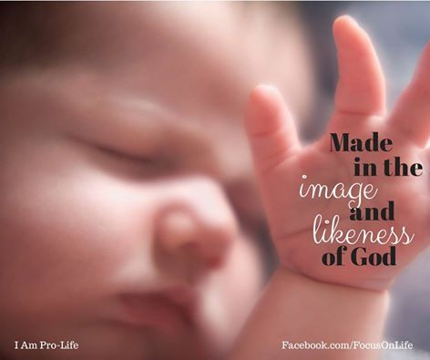

718 E Queen Street, Strasburg, VA 22657, 540-465-4744 msg ph
https://graceevfreechurchva.org
Please turn off or mute cell phones
Notes:

