Today’s Service
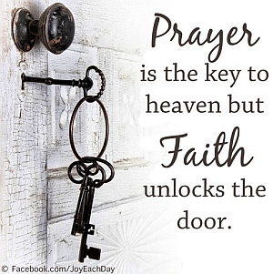
June 10, 2018
- Call to Worship
- Hymn
- Announcements
- Prayer Requests
- Music
- Sermon
- Offering


From the Pastor

This Sunday is Father’s Day! Consequently we have a essage for and about dads. Did you know that every new title we take in our relationships has a corresponding Biblical job description? What is our duty as a son or daughter? What is it to know Christ? What is it to be a young man or woman? What is it to be a dad…a grandfather? As the manual which applies to each and every one of us, the Bible not only has these definitions but those things which, as we graduate in life, become our responsibilities. Seek wisdom and understanding from the Word of God…and live up to God’s expectations!
Pastor Tony
Church Information
Last Week’s giving: $ 234 Month to date: $ 1,304
Weekly Target: $ 875 Previous month: $ 2,599
Year to Date: $ 17,033 Monthly Target: $ 3,500
YTD target: $20,125 (-3,092) Building Fund: $ 10,580
Adult Sunday School 9:45 am………………………………….. Linda Fraley
Elders
Tony Raker (Pastor)..…………………........... tonyraker@yahoo.com
Delmas (Moe) Ritenour ……………………….. moemar@shentel.net
Finance: Anthony Sinecoff……………………….. sinecoff@gmail.com
Linda Fraley …………………………….. lindaf12@shentel.net

Media: Rob Moses, Scott Tucker, & Tammy Copeland
Bulletin: Rob Moses ……………. admin@graceevfreechurchva.org

Breakfast: Tammy Copeland …….…tammyscopeland@gmail.com

Grace Evangelical Free Church
718 E Queen Street, Strasburg, VA 22657, 540-465-4744 msg ph
https://graceevfreechurchva.org
Please put cell phones on vibrate!
Notes:



