Today’s Service
June 21, 2020
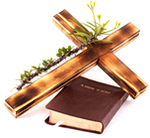
- Call to Worship
- Hymn
- Announcements
- Prayer Requests
- Music
- Sermon
- Offering (on table)
From the Pastor
Father’s Day is a day set apart to celebrate fatherhood, recognize the influence of fathers in our homes and society, and foster paternal bonds. When Abram’s name was changed to Abraham, God told him, “I have made you a father of many nations” (Genesis 17:5), clearly indicating fatherhood as a place of honor in His eyes. The apostle Paul taught that to honor one’s earthly father is not only a commandment but the first commandment that, when obeyed, has a promise of things going well and living long on the earth (Ephesians 6:2-3). For the sake of the church, society, family and yourself – honor your father.
Pastor Tony
Church Information

Last Week’s giving:
$621
Elders
Tony Raker (Pastor)..………………. pastor@graceevfreechurchva.org
Delmas (Moe) Ritenour….………………………….. moemar@shentel.net
Finance: Linda Fraley ……………………………….. lindaf12@shentel.net

IT & Media: Rob Moses & Scott Tucker
Bulletin: Rob Moses ………………. admin@graceevfreechurchva.org
Breakfast: Tammy Copeland ……….…tammyscopeland@gmail.com
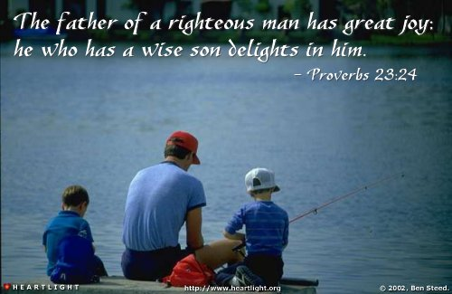

718 E Queen Street, Strasburg, VA 22657, 540-465-4744 msg ph
https://graceevfreechurchva.org
Please turn off or mute cell phones
Notes:

