Today’s Service
July 12th, 2020
- Call to Worship
- Hymn
- Announcements
- Prayer Requests
- Music
- Sermon
- Offering (on table)
From the Pastor
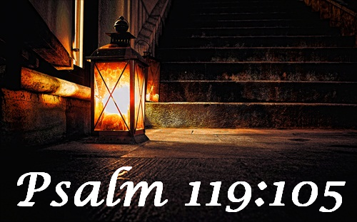
We have decisions to make in life, some of which prove life-altering. Five biblical steps to a right decision include: 1. Pray (James 1:5); 2. Seek biblical wisdom (Psalm 119:105); 3. Seek godly counsel (Proverbs 15:22); 4. Trust the Lord with your decision (Proverbs 3:5-6); 5. Give praise to God for your success. When your decisions result in personal success, the temptation is to believe it is due to your own power, talent, or genius. However, it is God who blesses our efforts and gives strength: “A man can receive only what is given him from heaven” (John 3:27).

. Pastor Tony
Church Information

Last Week’s giving:
$2,521
Elders
Tony Raker (Pastor)..………………. pastor@graceevfreechurchva.org
Delmas (Moe) Ritenour….………………………….. moemar@shentel.net
Finance: Linda Fraley ……………………………….. lindaf12@shentel.net

IT & Media: Rob Moses & Scott Tucker
Bulletin: Rob Moses ………………. admin@graceevfreechurchva.org
Breakfast: Tammy Copeland ……….…tammyscopeland@gmail.com
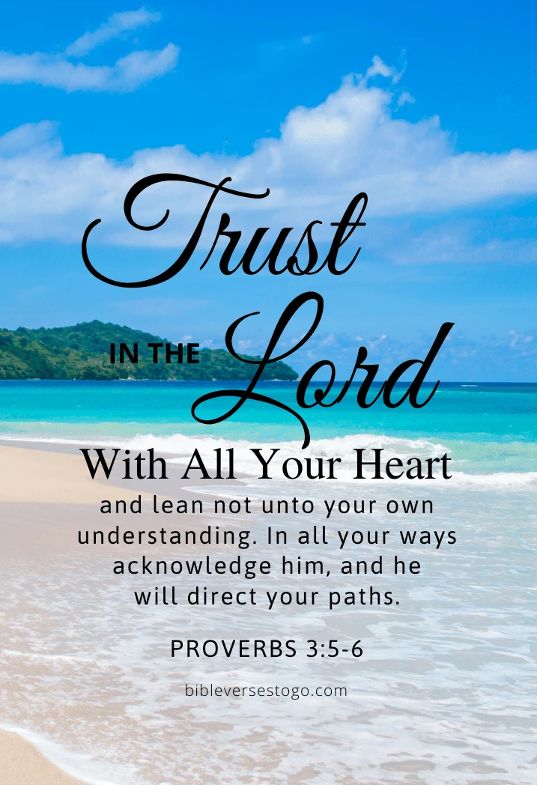

718 E Queen Street, Strasburg, VA 22657, 540-465-4744 msg ph
https://graceevfreechurchva.org
Please turn off or mute cell phones
Notes:

