Today’s Service
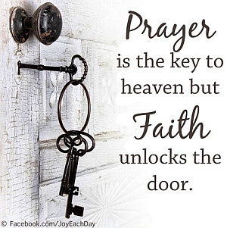
July 15, 2018
- Call to Worship
- Hymn
- Announcements
- Prayer Requests
- Music
- Sermon
- Offering

From the Pastor

In Ephesians 2:10, there is room for noting except the function of fulfilling the perfect will God. This is done with “good works” – actions and reactions which reflect the reality of God and His goodness in our walk. God has saved us, “in order to make known the riches of his glory for vessels of mercy, which he has prepared beforehand for glory” (Romans 9:23). The specificity of our salvation extends the “good works” which will occupy our time and effort for the remainder of our lives…and beyond. As we yield each and every circumstance to the Holy Spirit and His leading, we invite His presence, sense His direction, feel His strength and act upon His impulse…as “vessels of mercy”.
Pastor Tony
Church Information
Last Week’s giving: $ 274 Month to date: $ 778
Weekly Target: $ 800 Previous month: $ 2,754
Year to Date: $ 18,983 Monthly Target: $ 3,500
YTD target: $19,261 (-4,364) YTD Target: $ 23,625
Adult Sunday School 9:45 am………………………………….. Linda Fraley
Elders
Tony Raker (Pastor)..…………………........... tonyraker@yahoo.com
Delmas (Moe) Ritenour ……………………….. moemar@shentel.net
Finance: Anthony Sinecoff……………………….. sinecoff@gmail.com
Linda Fraley …………………………….. lindaf12@shentel.net

Media: Rob Moses, Scott Tucker, & Tammy Copeland
Bulletin: Rob Moses ……………. admin@graceevfreechurchva.org
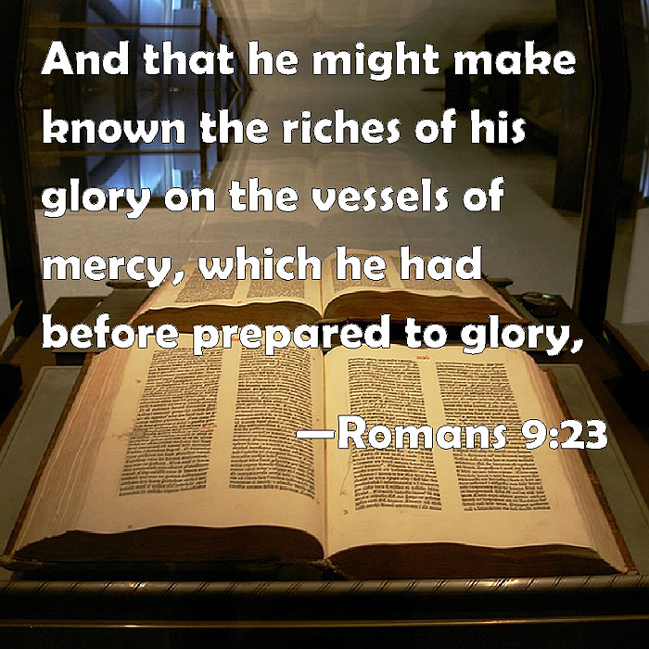
Breakfast: Tammy Copeland …….…tammyscopeland@gmail.com

Grace Evangelical Free Church
718 E Queen Street, Strasburg, VA 22657, 540-465-4744 msg ph
https://graceevfreechurchva.org
Please put cell phones on vibrate!
Notes:
Happy Anniversary Art & Betty Cheny!



