Today’s Service
July 26th, 2020
- Call to Worship
- Hymn
- Announcements
- Prayer Requests
- Music
- Sermon
- Offering (on table)
From the Pastor
Ps. 46:1 contains a description of God and a wonderful promise based on His character: “God is our refuge and strength, an ever-present help in trouble.” The next verse should be our: “Therefore we will not fear.” True peace will not come until we are with the Lord in “the city of God, the holy place where the Most High dwells” (v 4). This means that, in this world, we may experience hurt, and, eventually, we will die. But in the midst of it all, God is working everything out for good (Rom. 8:28). For those who belong to God, even the bad stuff has a good end! We are everlastingly safe. Because God promises to be our refuge and strength, we do not fear. Because He is an ever-present help in trouble, those who belong to Him can commit their way to Him and take their rest. God is saying, “Be still. Trust me. I’ve got this.” Just be sure to give Him your circumstance in the first place!

. Pastor Tony
Church Information

Last Week’s giving:
$1,562
Elders
Tony Raker (Pastor)..………………. pastor@graceevfreechurchva.org
Delmas (Moe) Ritenour….………………………….. moemar@shentel.net
Finance: Linda Fraley ……………………………….. lindaf12@shentel.net

IT & Media: Rob Moses & Scott Tucker
Bulletin: Rob Moses ………………. admin@graceevfreechurchva.org
Breakfast: Tammy Copeland ……….…tammyscopeland@gmail.com
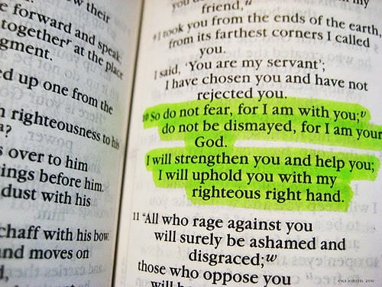

718 E Queen Street, Strasburg, VA 22657, 540-465-4744 msg ph
https://graceevfreechurchva.org
Please turn off or mute cell phones
Notes:

