Today’s Service
Aug 16th , 2020
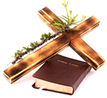
- Call to Worship
- Hymn
- Announcements
- Prayer Requests
- Music
- Sermon
- Offering (on table)
From the Pastor
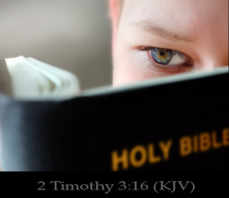
How can believers NOT be conformed to the world? By being “transformed by the renewing of our minds” (Romans 12:2). We do this primarily through the power of God’s Word to transform us. We need to hear (Romans 10:17), read (Revelation 1:3), study (Acts 17:11), memorize (Psalm 119:9-11), and meditate (Psalm 1:2-3) on Scripture. The Word of God, ministered in our hearts by the Holy Spirit, is the only power on earth that can transform us from worldliness to true spirituality. In fact, it is all we need to be made “complete, thoroughly equipped for every good work” (2 Timothy 3:16). The result is that we will be “able to test and approve what God's will is—his good, pleasing and perfect will” (Romans 12:2b). It is the will of God for every believer to be a living sacrifice for Jesus Christ.

Pastor Tony
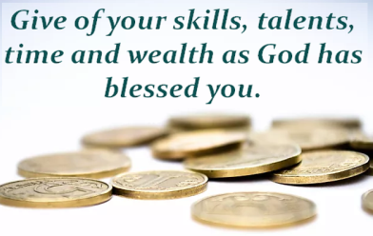
Church Information

Last Week’s giving:
$1,943
Elders
Tony Raker (Pastor)..………………. pastor@graceevfreechurchva.org
Delmas (Moe) Ritenour….………………………….. moemar@shentel.net
Finance: Linda Fraley ……………………………….. lindaf12@shentel.net

IT & Media: Rob Moses & Scott Tucker
Bulletin: Rob Moses ………………. admin@graceevfreechurchva.org
Breakfast: Tammy Copeland ……….…tammyscopeland@gmail.com
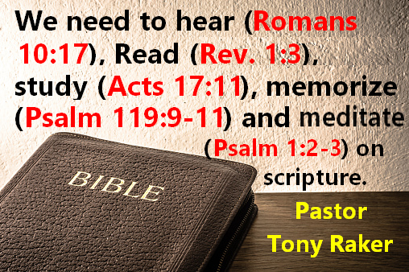

718 E Queen Street, Strasburg, VA 22657, 540-465-4744 msg ph
https://graceevfreechurchva.org
Please turn off or mute cell phones
Notes:

