Today’s Service
Aug 2nd , 2020
- Call to Worship
- Hymn
- Announcements
- Prayer Requests
- Music
- Sermon
- Communion
- Offering (on table)
From the Pastor
Biblical prophecy plays two roles: foretells the future; explains what the positive or negative results of future events will be. Biblical prophecy is normally very specific as to how it will affect someone or something. It is always dependable and worthy of our complete trust. We can allow prophecy to help shape our lives, giving us direction and guidance in serving our Lord, a source of strength and instruction. Unlike what we hear called “prophecy” today, both in the church and outside the church, true biblical prophecy is always accurate and precise. What God prophesies always occurs. A roadmap of the future, failing to understand prophecy is to miss one of the greatest gifts of God: “The entirety of your word is truth, each of your righteous judgments endures forever” (Ps. 119:160).
. Pastor Tony
Church Information

Last Week’s giving:
$470
Elders
Tony Raker (Pastor)..………………. pastor@graceevfreechurchva.org
Delmas (Moe) Ritenour….………………………….. moemar@shentel.net
Finance: Linda Fraley ……………………………….. lindaf12@shentel.net

IT & Media: Rob Moses & Scott Tucker
Bulletin: Rob Moses ………………. admin@graceevfreechurchva.org
Breakfast: Tammy Copeland ……….…tammyscopeland@gmail.com
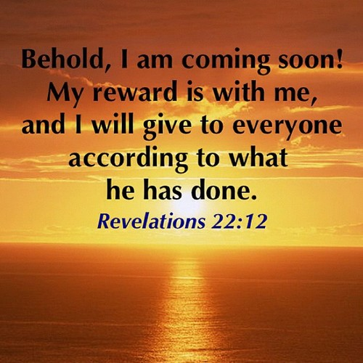

718 E Queen Street, Strasburg, VA 22657, 540-465-4744 msg ph
https://graceevfreechurchva.org
Please turn off or mute cell phones
Notes:

