Today’s Service
Aug 23rd, 2020
- Call to Worship
- Hymn
- Announcements
- Prayer Requests
- Music
- Sermon
- Offering (on table)
From the Pastor
It was common in ancient pagan nations to perceive each god or goddess as having a particular domain or sphere of power on the earth. But the truth that ‘God is the God of the hills and valleys’ originates from the narrative of two battles in the book of 1 Kings. God gave Israel victory both at Samaria in the hills and at Aphek in the valleys to show that, unlike the ineffective and finite gods of Canaan, God is sovereign over all territories and regions. It is a mistake to think of God as only a “hill god” or a “valley god.” He is the God of both the hills and the valleys. In fact, He is the all-powerful, infinite Ruler of the whole earth. “The earth is the LORD’s, and everything in it, the world, and all who live in it” (Psalm 24:1). Think of this in your next hill/valley experience!
Pastor Tony
Church Information

Last Week’s giving:
$2,051
Elders
Tony Raker (Pastor)..………………. pastor@graceevfreechurchva.org
Delmas (Moe) Ritenour….………………………….. moemar@shentel.net
Finance: Linda Fraley ……………………………….. lindaf12@shentel.net

IT & Media: Rob Moses & Scott Tucker
Bulletin: Rob Moses ………………. admin@graceevfreechurchva.org
Breakfast: Tammy Copeland ……….…tammyscopeland@gmail.com
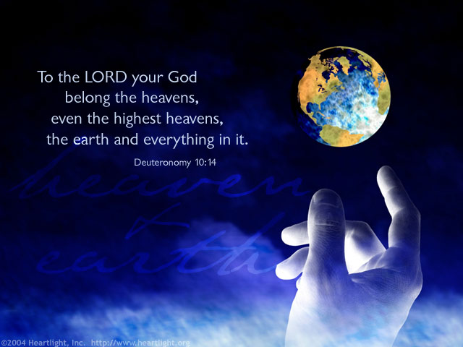

718 E Queen Street, Strasburg, VA 22657, 540-465-4744 msg ph
https://graceevfreechurchva.org
Please turn off or mute cell phones
Notes:

