Today’s Service
Aug 30th, 2020
- Call to Worship
- Hymn
- Announcements
- Prayer Requests
- Music
- Sermon
- Offering (on table)
From the Pastor
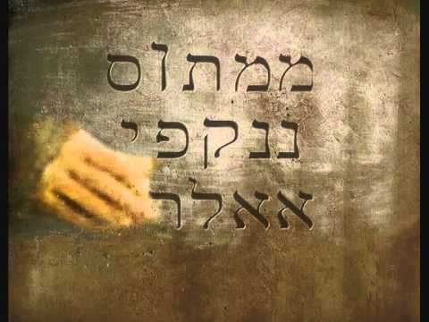
The phrase ‘mene mene tekel upharsin’ appears in Daniel 5, along with its translation: “numbered, numbered, weighed, divided.” The handwriting on the wall proved true and fatal for the dissolute Belshazzar as the kingdom of Babylon was divided between the Medes and Persians, and it happened that very night (Daniel 5:30–31). The appearance of ‘mene mene tekel upharsin’ on the king’s wall is a reminder that whatever we sow, that we will also reap (Galatians 6:7–8). God is the Judge; He justly weighs all matters and metes out retribution in His time (Psalm 94:2). Sometimes God speaks very clearly into our lives, convicting us of sin and warning us of pending judgment (see John 16:8). Point being: it does not pay to ignore the “handwriting on the wall.”
Pastor Tony
Church Information

Last Week’s giving:
$470
Elders
Tony Raker (Pastor)..………………. pastor@graceevfreechurchva.org
Delmas (Moe) Ritenour….………………………….. moemar@shentel.net
Finance: Linda Fraley ……………………………….. lindaf12@shentel.net

IT & Media: Rob Moses & Scott Tucker
Bulletin: Rob Moses ………………. admin@graceevfreechurchva.org
Breakfast: Tammy Copeland ……….…tammyscopeland@gmail.com
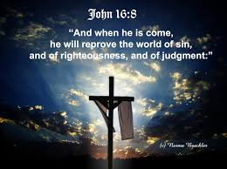

718 E Queen Street, Strasburg, VA 22657, 540-465-4744 msg ph
https://graceevfreechurchva.org
Please turn off or mute cell phones
Notes:

