**Today’s Service**

**Sept 1, 2019**

1. 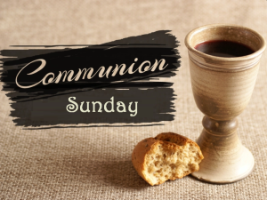 Call to Worship
2. Hymn
3. Announcements
4. Prayer Requests
5. Music
6. Sermon
7. Communion
8. Offering

**From the Pastor**

In the Old Testament, the Israelites repeatedly rejected God’s good Law, forgot His goodness toward them, and were disobedient to Him: “**They forgot what he had done, the wonders he had shown them**” (**Ps. 78:11**).  Despite the salvation Jesus has made possible, many Christians today are guilty of the same.  Yet God’s goodness should lead to thankfulness on our part: “**Give thanks to the LORD, for He is good; His love endures forever**” (**Ps. 107:1**).  God invites us to seek Him and to “**taste and see that the Lord is good; blessed is the one who takes refuge in Him**” (**Ps. 34:8**). Choose to obey!

Pastor Tony

**Church Information**

Last Week’s giving: $ 280 Month to date: $ 4,470

Weekly Goal: $ 1,200 Previous month: $ 4,370

2019 Weekly Average: $ 1,157

**Elders**

Tony Raker (**Pastor**)..……………………........... [tonyraker@yahoo.com](mailto:tonyraker@yahoo.com)

Delmas (Moe) Ritenour….………………………….. [moemar@shentel.net](mailto:moemar@shentel.net)

Finance: Linda Fraley ……………………………….. [lindaf12@shentel.net](mailto:lindaf12@shentel.net)

### IT & Media: Rob Moses & Scott Tucker

Bulletin: Rob Moses ………………. [admin@graceevfreechurchva.org](mailto:admin@graceevfreechurchva.org)

Breakfast: Tammy Copeland ……….…[tammyscopeland@gmail.com](mailto:tammyscopeland@gmail.com)

Adult Sunday School 9:45 am…………………………………….. Linda Fraley

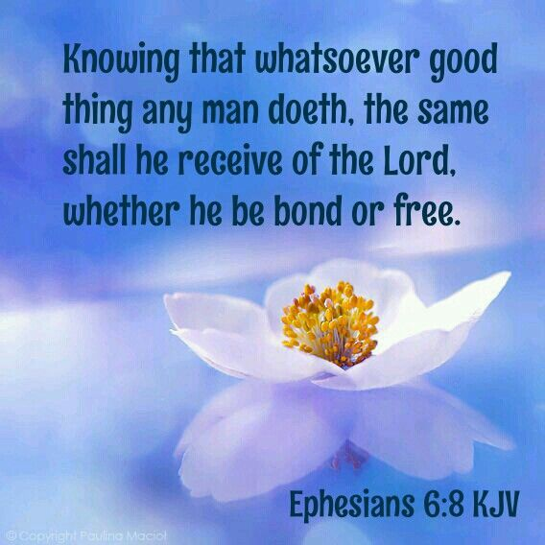

Grace Evangelical Free Church

718 E Queen Street, Strasburg, VA 22657, 540-465-4744 msg ph

<https://graceevfreechurchva.org>

Please turn off or mute cell phones

Notes:

**Next Breakfast 9/21/2019**

