Today’s Service
Sept 6th, 2020
- Call to Worship
- Hymn
- Announcements
- Prayer Requests
- Music
- Sermon
- Communion
- Offering (on table)
From the Pastor
Matthew’s account of the resurrection of Christ presents two very different results of that miracle. When the angel descended to the tomb and rolled the stone away, “The guards were so shaken by fear of him that they became like dead men” (Mt. 28:4). The angel let them lie there. But later, the angel spoke to the women who visited the tomb: “The angel told the women, “Don’t be afraid, because I know you are looking for Jesus who was crucified. 6 He is not here. For he has risen, just as he said” (vv 5–6). With one group, God takes away their fear; with the other group, He allows fear to overwhelm them. The difference was one of belief versus unbelief. The Bible’s commands to “fear not” are plentiful and occur in a variety of contexts. As God’s people, we are not to be fearful. We have no reason to live in fear.
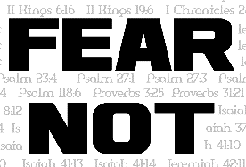
Pastor Tony
Church Information

Last Week’s giving:
$525
Elders
Tony Raker (Pastor)..………………. pastor@graceevfreechurchva.org
Delmas (Moe) Ritenour….………………………….. moemar@shentel.net
Finance: Linda Fraley ……………………………….. lindaf12@shentel.net

IT & Media: Rob Moses & Scott Tucker
Bulletin: Rob Moses ………………. admin@graceevfreechurchva.org
Breakfast: Tammy Copeland ……….…tammyscopeland@gmail.com
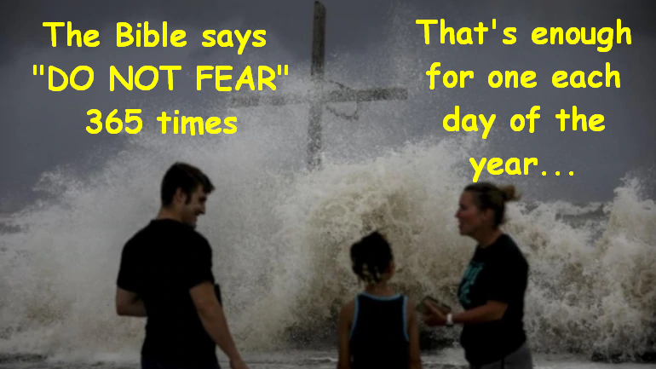

718 E Queen Street, Strasburg, VA 22657, 540-465-4744 msg ph
https://graceevfreechurchva.org
Please turn off or mute cell phones
Notes:

