Today’s Service
Sept 20th, 2020
- Call to Worship
- Hymn
- Announcements
- Prayer Requests
- Music
- Sermon
- Offering (on table)
From the Pastor
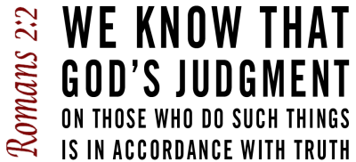
The Bible tells us that the Holy Spirit will convict the world of sin (Jn. 16:8). It is not simply a guilty conscience or even shame, feelings naturally experienced. The word convict is the Greek word elencho, which means “to convince someone of the truth; to reprove; to accuse, refute, or cross-examine a witness.” The Holy Spirit acts as a prosecuting attorney who exposes evil, reproves evildoers, and convinces people they need a Savior. When David was convicted by the Holy Spirit, he cried out, “Against you, you only, have I sinned and done what is evil in your sight” (Ps. 51:4). We are convicted when intensely aware of the wrath exposed to our souls (Rom. 1:18; 2:5). When the Philippian jailer fell and cried out, “Sirs, what must I do to be saved?” he was under conviction (Acts 16:30); certain that, without a Savior, he would die.
. Pastor Tony
Church Information

Last Week’s giving:
$2,662
Elders
Tony Raker (Pastor)..………………. pastor@graceevfreechurchva.org
Delmas (Moe) Ritenour….………………………….. moemar@shentel.net
Finance: Linda Fraley ……………………………….. lindaf12@shentel.net

IT & Media: Rob Moses & Scott Tucker
Bulletin: Rob Moses ………………. admin@graceevfreechurchva.org
Breakfast: Tammy Copeland ……….…tammyscopeland@gmail.com
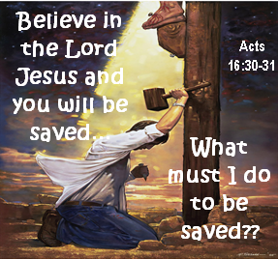

718 E Queen Street, Strasburg, VA 22657, 540-465-4744 msg ph
https://graceevfreechurchva.org
Please turn off or mute cell phones
Notes:

