Today’s Service
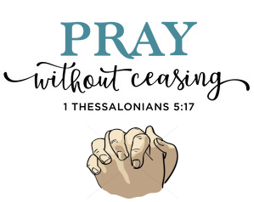
Jan 10, 2021
- Call to Worship
- Hymn
- Announcements
- Prayer Requests
- Music
- Sermon
From the Pastor
The Greek words translated “fellowship” in the New Testament mean essentially a partnership to the mutual benefit of those involved. Christian fellowship, then, is the mutually beneficial relationship between Christians who can’t have the identical relationship with those outside of the faith. The mystery and privilege that is Christian fellowship is that it exists because God has enabled it by His grace (John 17:23). Our hearts and minds are “other-worldly” because we follow Jesus Christ, who said that His kingdom is not of this world (John 18:36). The importance of true Christian fellowship is that it reinforces these things in our hearts and minds, focusing us, together, on Christ and the advancement of His Kingdom.
Pastor Tony
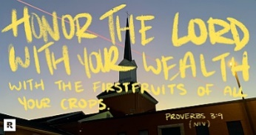
Church Information
Last Week’s giving:
$1,550 + Online: $0 = $1,550
Elders
Tony Raker (Pastor)..………………. pastor@graceevfreechurchva.org
Delmas (Moe) Ritenour….………………………….. moemar@shentel.net
Finance: Linda Fraley ……………………………….. lindaf12@shentel.net

IT & Media: Rob Moses & Scott Tucker
Bulletin: Rob Moses ………………. admin@graceevfreechurchva.org
Breakfast: Tammy Copeland ……….…tammyscopeland@gmail.com
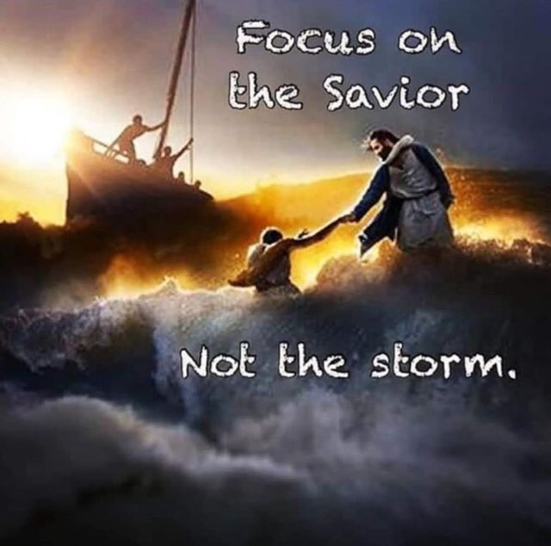
718 E Queen Street, Strasburg, VA 22657, 540-465-4744 msg ph
https://graceevfreechurchva.org
Notes:

