Today’s Service
Jan 20, 2019
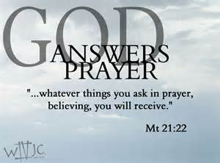
- Call to Worship
- Hymn
- Announcements
- Prayer Requests
- Music
- Sermon
- Offering
From the Pastor
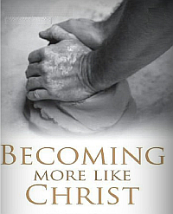
God's desire for all who know Him is for us to become more like Christ (Romans 8:29). We do this by first growing in our knowledge of Christ. It stands to reason that we cannot grow to be like someone we don't know. Among other reasons, we are to know and understand Christ so that we will be secure in the faith. 2 Peter 3:17-18 shows us that growing in the knowledge of Christ will preserve us from faith-destroying error. Of course, knowledge alone will not produce a Christ-like character. According to Romans 12:1-2, the knowledge we gain from God's Word must impact our hearts and convict us of the need to obey what we have learned. The deeper our knowledge of Christ, the deeper our understanding of Him, and the more like Him we become.
Pastor Tony
Church Information
Last Week’s giving: $ 0 Month to date: $ 2,434
Weekly Goal: $ 875 Previous month: $ 4,940
Weekly Average: & 811 Monthly Goal: $ 3,500
Elders
Tony Raker (Pastor)..……………………........... tonyraker@yahoo.com
Delmas (Moe) Ritenour ………………………….. moemar@shentel.net
Finance: Anthony Sinecoff………………………….. sinecoff@gmail.com
Linda Fraley ……………………………….. lindaf12@shentel.net

Media: Rob Moses & Scott Tucker
Bulletin: Rob Moses ………………. admin@graceevfreechurchva.org
Breakfast: Tammy Copeland ……….…tammyscopeland@gmail.com
Adult Sunday School 9:45 am…………………………………….. Linda Fraley
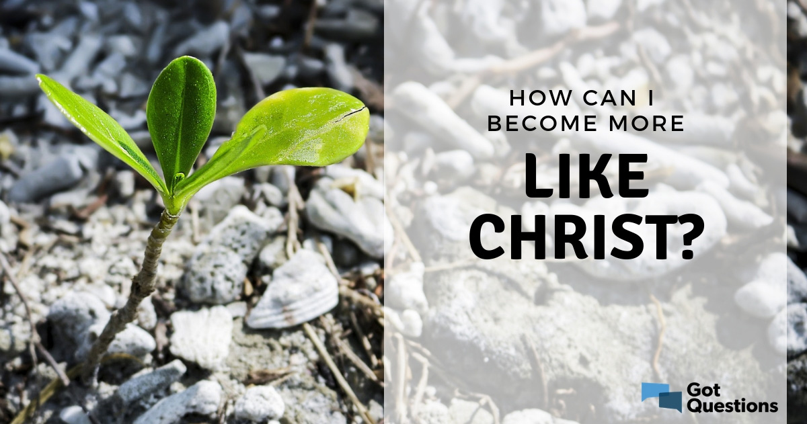

Grace Evangelical Free Church
718 E Queen Street, Strasburg, VA 22657, 540-465-4744 msg ph
https://graceevfreechurchva.org
Please turn off or mute cell phones
Notes:

Next Breakfast is February 16th.

Prevent truth decay. Brush up on your Bible.

