Today’s Service
Jan 27, 2019
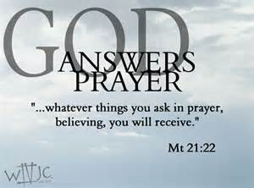
- Call to Worship
- Hymn
- Announcements
- Prayer Requests
- Music
- Sermon
- Offering
From the Pastor
The fact that we should serve God is obvious in Scripture (see Luke 4:8). The Bible offers several motivations for our service. We want to serve God because “we are receiving a kingdom that cannot be shaken” (Hebrews 12:28), because our service supplies “the needs of the Lord’s people” (2 Corinthians 9:12), because our service proves our faith and causes others to praise God (2 Corinthians 9:13), and because God sees and rewards our labor of love (Hebrews 6:10). If you want to want to serve God, the key is to get to know Him! Ask the Holy Spirit to reveal more of God to you (John 16:13). When we truly know God, who is love (1 John 4:8), our natural response is a desire to love and serve Him in return.
Pastor Tony
Church Information
Last Week’s giving: $ 1,100 Month to date: $ 3,534
Weekly Goal: $ 875 Previous month: $ 4,940
2019 Weekly Average: $ 1,125 Monthly Goal: $ 3,500
Elders
Tony Raker (Pastor)..……………………........... tonyraker@yahoo.com
Delmas (Moe) Ritenour ………………………….. moemar@shentel.net
Finance: Anthony Sinecoff………………………….. sinecoff@gmail.com
Linda Fraley ……………………………….. lindaf12@shentel.net

Media: Rob Moses & Scott Tucker
Bulletin: Rob Moses ………………. admin@graceevfreechurchva.org
Breakfast: Tammy Copeland ……….…tammyscopeland@gmail.com
Adult Sunday School 9:45 am…………………………………….. Linda Fraley

Grace Evangelical Free Church
718 E Queen Street, Strasburg, VA 22657, 540-465-4744 msg ph
https://graceevfreechurchva.org
Please turn off or mute cell phones
Notes:

Next Breakfast is February 16th.
Communion next week!

Try Jesus. If you don’t like him, the devil will always
take you back.

