Today’s Service
Jan 3, 2021
- Call to Worship
- Hymn
- Announcements
- Prayer Requests
- Music
- Sermon
- Communion
From the Pastor
After exhorting the believers in Galatia and warning them of the things they should avoid (Gal. 5:1—6:8), Paul knew they would be feeling overwhelmed with the responsibilities of the Christian life. So he encourages them with the words of v. 9: “Let us not become weary in doing good, for at the proper time we will reap a harvest if we do not give up.” In view of our own natural weakness and the opposition of the kingdom of evil and evil men, the best intentions for doing good can be easily derailed. But there are things we can do to minimize weariness. Jesus scheduled times of rest; did not overcommit (Mark 6:31). Discernment is essential. God will provide. He will ordain the means to accomplish His ends. We will not give up, because our Lord is faithful: “Always give yourselves fully to the work of the Lord, because you know that your labor in the Lord is not in vain” (1 Cor. 15:58). Is it worth serving the Lord? Paul says, “Yes!”
Pastor Tony
Church Information
Last Week’s giving:
$675 + Online: $340 = $1,015
Elders
Tony Raker (Pastor)..………………. pastor@graceevfreechurchva.org
Delmas (Moe) Ritenour….………………………….. moemar@shentel.net
Finance: Linda Fraley ……………………………….. lindaf12@shentel.net

IT & Media: Rob Moses & Scott Tucker
Bulletin: Rob Moses ………………. admin@graceevfreechurchva.org
Breakfast: Tammy Copeland ……….…tammyscopeland@gmail.com
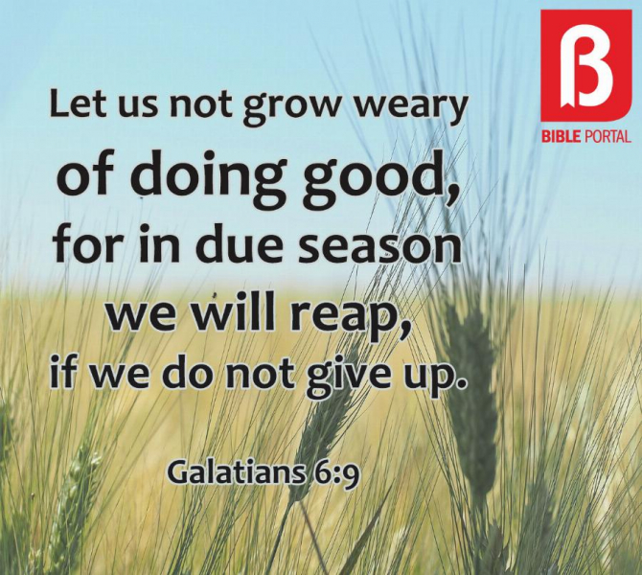
718 E Queen Street, Strasburg, VA 22657, 540-465-4744 msg ph
https://graceevfreechurchva.org
Please turn off or mute cell phones
Notes:

