Today’s Service
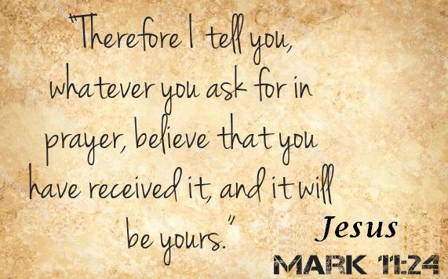
October 6, 2019
- Call to Worship
- Hymn
- Announcements
- Prayer Requests
- Music
- Sermon
- Communion
- Offering
From the Pastor
The Bible is clear that the spirit world is every bit as real as the physical universe (Eph. 6:12). There is an unseen battle taking place around us every moment between God's holy angels and the forces of darkness (Dan. 10:12-14; Eph. 6:10-17; Jude 1:9). If we are vigilant as the Lord commands, we will not be caught unprepared by Satan’s attacks (1 Pet. 5:8; 2 Cor. 2:11). And we have the promise of God that His Holy Spirit is stronger than any of Satan's schemes (1 Jn. 4:4). God has given His children everything we need to stand firm against any spiritual attack of our enemy. The apostle Paul calls this the "armor of God" (Eph. 6:11). So, stand…and be unmoved!
Pastor Tony
Church Information
Last Week’s giving: $ 455 Month to date: $ 3,607
Weekly Goal: $ 1,200 Previous month: $ 4,470
2019 Weekly Average: $ 1,101
Elders
Tony Raker (Pastor)..……………………........... tonyraker@yahoo.com
Delmas (Moe) Ritenour….………………………….. moemar@shentel.net
Finance: Linda Fraley ……………………………….. lindaf12@shentel.net

IT & Media: Rob Moses & Scott Tucker
Bulletin: Rob Moses ………………. admin@graceevfreechurchva.org
Breakfast: Tammy Copeland ……….…tammyscopeland@gmail.com
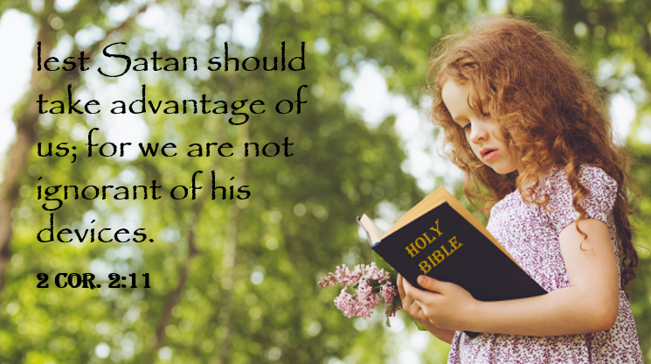
Grace Evangelical Free Church
718 E Queen Street, Strasburg, VA 22657, 540-465-4744 msg ph
https://graceevfreechurchva.org
Please turn off or mute cell phones
Notes:

Last Breakfast of 2019 is 10/19/2019
Why is lemon juice made with artificial flavor and dishwashing liquid with real lemons?

