Today’s Service
Oct 11th, 2020
- Call to Worship
- Hymn
- Announcements
- Prayer Requests
- Music
- Sermon
- Offering (on table)
From the Pastor
There are at least 169 verses in the Bible that refer to the ways God provides for us. Philippians 4:19 puts it simply: “My God will supply all your needs according to His riches in glory in Christ Jesus.” Like any good parent, God would never give us what He knows would harm us. His intent is to help us develop Christlikeness so that we become salt and light in the world (Matthew 5:13–14). God does not want us to see Him as a heavenly source of mere material possessions. Acquiring things is not the fundamental goal of this life (Luke 12:15). God’s provision extends to His ongoing relationship to all of His creation, which is deeply dependent on Him (Psalm 104:21). Often, we take for granted the rain that falls, the sun that comes up every morning, the refreshing winds that blow, crops grow and the tides that cleanse our shores and invigorate the life in our vast oceans. But all these things are watched over by our loving God in His provision for us.
Pastor Tony
Church Information
Last Week’s giving:
$737 + Online: $900 = $1,637
Elders
Tony Raker (Pastor)..………………. pastor@graceevfreechurchva.org
Delmas (Moe) Ritenour….………………………….. moemar@shentel.net
Finance: Linda Fraley ……………………………….. lindaf12@shentel.net

IT & Media: Rob Moses & Scott Tucker
Bulletin: Rob Moses ………………. admin@graceevfreechurchva.org
Breakfast: Tammy Copeland ……….…tammyscopeland@gmail.com
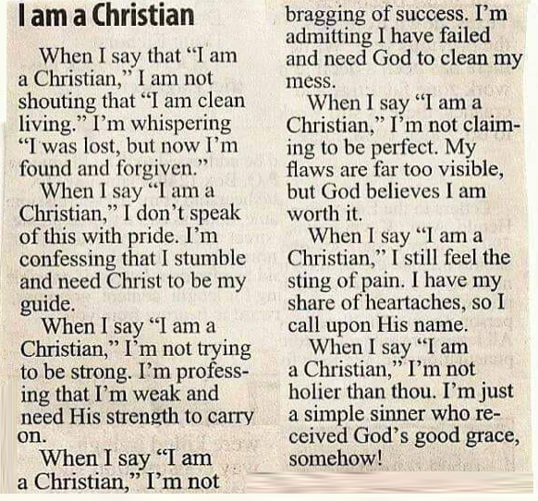
718 E Queen Street, Strasburg, VA 22657, 540-465-4744 msg ph
https://graceevfreechurchva.org
Please turn off or mute cell phones
Notes:

