Today’s Service
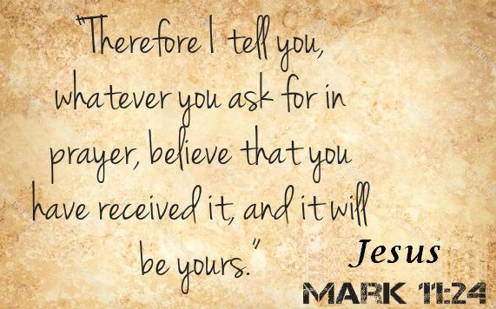
October 13, 2019
- Call to Worship
- Hymn
- Announcements
- Prayer Requests
- Music
- Sermon
- Offering
From the Pastor
The key to the spiritual battle plan found in Eph. 6:10-18 is that we must be strong in the Lord and in His power, not in our own power which is no match for the devil and his forces. Jesus is our ultimate example when it comes to warding off spiritual attacks. Observe how Jesus handled direct attacks from Satan when He was tempted by him in the wilderness (Mt. 4:1-11). Each temptation was answered the same way—with the words “It is written” and a quote from the Scriptures. Jesus knew the Word of the living God is the most powerful weapon against the temptations of the devil. If Jesus Himself used the Word to counter the devil, do we dare to use anything less?
Pastor Tony
Church Information
Last Week’s giving: $ 810 Month to date: $ 810
Weekly Goal: $ 1,200 Previous month: $ 3,607
2019 Weekly Average: $ 1,093
Elders
Tony Raker (Pastor)..……………………........... tonyraker@yahoo.com
Delmas (Moe) Ritenour….………………………….. moemar@shentel.net
Finance: Linda Fraley ……………………………….. lindaf12@shentel.net

IT & Media: Rob Moses & Scott Tucker
Bulletin: Rob Moses ………………. admin@graceevfreechurchva.org
Breakfast: Tammy Copeland ……….…tammyscopeland@gmail.com
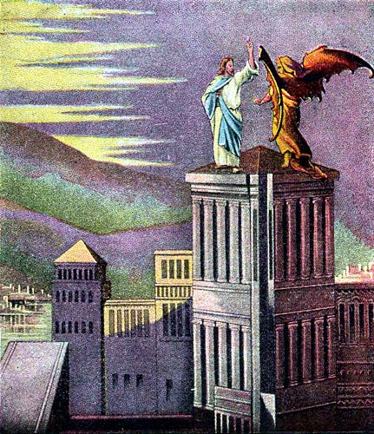
Grace Evangelical Free Church
718 E Queen Street, Strasburg, VA 22657, 540-465-4744 msg ph
https://graceevfreechurchva.org
Please turn off or mute cell phones
Notes:

Last Breakfast of 2019 is 10/19/2019 - NEXT WEEK!

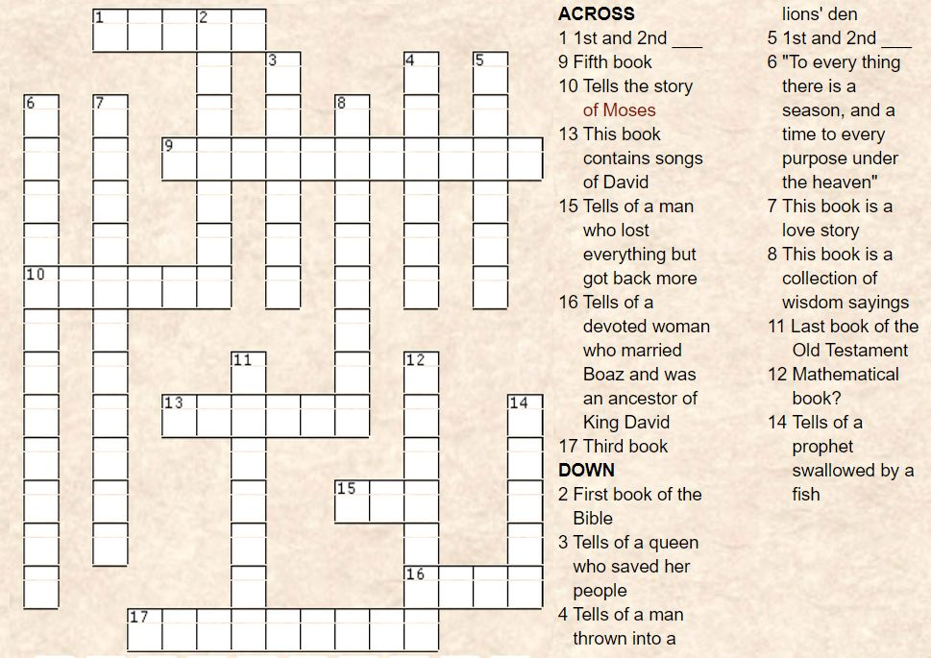
How well do you know the books of the old testament?

