Today’s Service
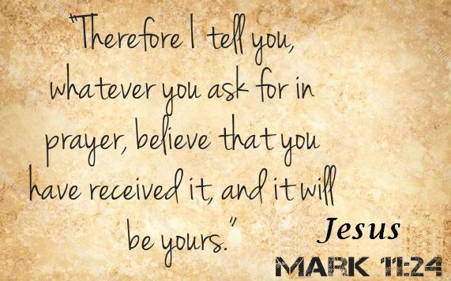
October 20, 2019
- Call to Worship
- Hymn
- Announcements
- Prayer Requests
- Music
- Sermon
- Offering
From the Pastor
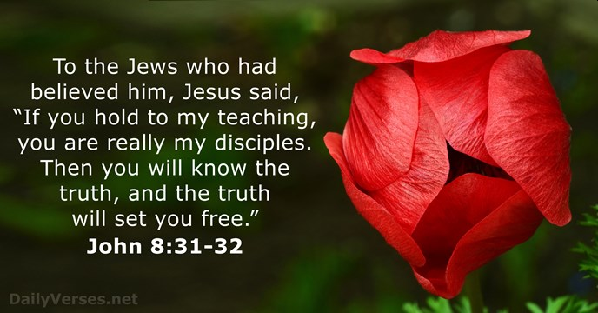
Satan uses Scripture for his own purpose, twisting it to sound as though it says something it doesn’t (Lk. 4:9–11). If we have not been diligent in our study and meditation on God’s truth, we are vulnerable to error. The false religions of the world can be persuasive when they quote Bible verses to support their error. Even Christians can be duped by smooth-sounding heresy if they do not have a solid grounding in the “whole counsel of God” (Acts 20:27). It is God’s desire that we grow daily in our understanding of Him and His Word so that we will remain faithful, “steadfast” to the end (Jn. 8:31; 2 Pt. 1:2; 3:18; 1 Jn. 2:24).
Pastor Tony
Church Information
Last Week’s giving: $ 3,100 Month to date: $ 3,910
Weekly Goal: $ 1,200 Previous month: $ 3,607
2019 Weekly Average: $ 1,142
Elders
Tony Raker (Pastor)..……………………........... tonyraker@yahoo.com
Delmas (Moe) Ritenour….………………………….. moemar@shentel.net
Finance: Linda Fraley ……………………………….. lindaf12@shentel.net

IT & Media: Rob Moses & Scott Tucker
Bulletin: Rob Moses ………………. admin@graceevfreechurchva.org
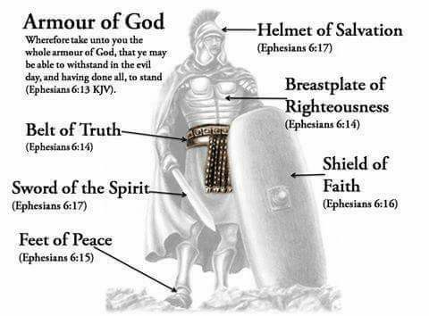
Breakfast: Tammy Copeland ……….…tammyscopeland@gmail.com
Grace Evangelical Free Church
718 E Queen Street, Strasburg, VA 22657, 540-465-4744 msg ph
https://graceevfreechurchva.org
Please turn off or mute cell phones
Notes:

