Today’s Service
Oct 25th, 2020
- Call to Worship
- Hymn
- Announcements
- Prayer Requests
- Music
- Sermon
- Offering (on table)
From the Pastor
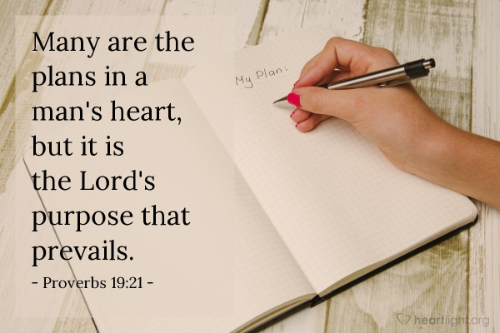
Above all things, God loves for us to demonstrate faith (Hebrews 11:6). Faith is trusting in the character of God before we see how He is going to work things out. He has given us His Word, and His promises still stand. As we see the ways He brings His promises to fulfillment, our trust in His faithfulness grows. Just as our trust in other people grows with daily interaction, our trust in God grows the same way. We trust Him when we know Him, and to know Him is to trust Him. When we know Him, we can rest in His goodness, even when we don’t understand the circumstances that seem to contradict it. We can trust that God’s plan for us will prevail (Proverbs 19:21). As a child trusts a loving father, we can trust our heavenly Father to do; and always do what is right.
Pastor Tony
Church Information
Last Week’s giving:
$601 + Online: $0 = $601
Elders
Tony Raker (Pastor)..………………. pastor@graceevfreechurchva.org
Delmas (Moe) Ritenour….………………………….. moemar@shentel.net
Finance: Linda Fraley ……………………………….. lindaf12@shentel.net

IT & Media: Rob Moses & Scott Tucker
Bulletin: Rob Moses ………………. admin@graceevfreechurchva.org
Breakfast: Tammy Copeland ……….…tammyscopeland@gmail.com
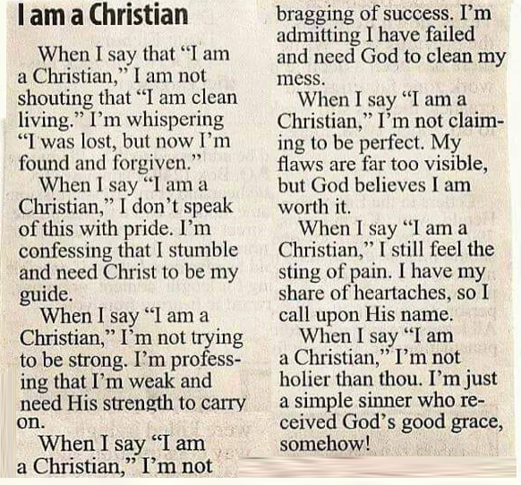
718 E Queen Street, Strasburg, VA 22657, 540-465-4744 msg ph
https://graceevfreechurchva.org
Please turn off or mute cell phones
Notes:

