Today’s Service
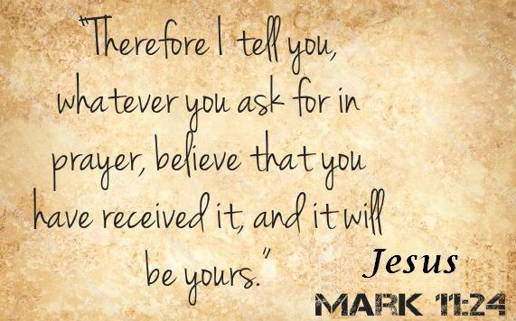
October 27, 2019
- Call to Worship
- Hymn
- Announcements
- Prayer Requests
- Music
- Sermon
- Offering (on table)
From the Pastor
God never calls without equipping (Hebrews 13: 20, 21). In fact, God doesn’t call the equipped but He equips the called. We hear much today about empowering. Whole industries have sprung up to empower people in all areas of their lives. Rejecting humanism, we have the Holy Spirit to empower us to do the tasks for which we have no power to do alone. He comes to help those who are helpless. He comes to strengthen and inspire. In other words, He is in your life in order to anoint you for your appointed task—the task God assigned to you before you were you to know!
Pastor Tony

Church Information
Last Week’s giving: $ 210 Month to date: $ 4,120
Weekly Goal: $ 1,200 Previous month: $ 3,607
2019 Weekly Average: $ 1,120
Elders
Tony Raker (Pastor)..……………………........... tonyraker@yahoo.com
Delmas (Moe) Ritenour….………………………….. moemar@shentel.net
Finance: Linda Fraley ……………………………….. lindaf12@shentel.net

IT & Media: Rob Moses & Scott Tucker
Bulletin: Rob Moses ………………. admin@graceevfreechurchva.org
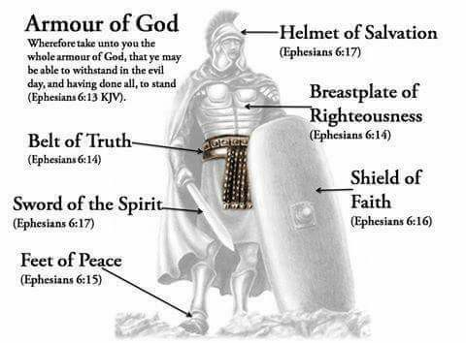
Breakfast: Tammy Copeland ……….…tammyscopeland@gmail.com
Grace Evangelical Free Church
718 E Queen Street, Strasburg, VA 22657, 540-465-4744 msg ph
https://graceevfreechurchva.org
Please turn off or mute cell phones
Notes:

